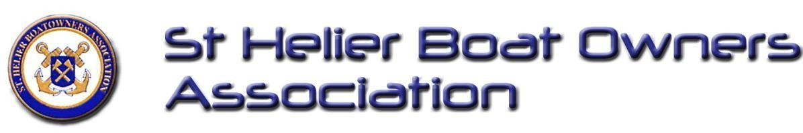
St Helier Boatowners Association Newsletter Issue #4 – Spring 2026

From the Chair

Welcome to the Spring 2026 Newsletter. With longer days and warmer weather on the horizon, it’s great to see St Helier’s marinas coming back to life. Your committee has been busy over the winter working with Ports of Jersey and our partners in JABOA to ensure our voices are heard on key issues, from mooring fees to infrastructure. We wish all members a fantastic and safe start to the 2026 season.

Phil James — Chair, StHBOA

🛠 The New Maintenance Tracker: Our Success Story

We are working closely with Ports of Jersey to ensure our harbour facilities remain in top condition. Our Repairs & Maintenance Tracker is now live, acting as a helpful tool to identify and monitor infrastructure needs: https://sthboa.org/maintenance-tracker.html

- Tracking Progress: You can now view completed tasks to see the improvements being made.
- See the Status: View a real-time list of outstanding issues and their current repair progress.
- Report a Fault: Spot a broken ladder or faulty pontoon? Let us know so we can add it to the list.
By documenting these faults, we provide Ports of Jersey with a clear, collaborative roadmap of what needs attention, helping to ensure our harbour fees are reinvested effectively.

📢 An Administrative Spring Clean
We have been busy behind the scenes tidying up our systems to make sure our communications are as smooth as possible for the new season.
We recently discovered a glitch with our website contact form that may have caused some of your messages to go astray. We have also been working hard to fix a "double-email" issue in our membership system that many of you flagged. To get everything back on an even keel, we have performed a system reset. This means:

- Email Preferences: We have reset these to ensure everyone receives essential notices like AGM invites and renewals.
- Catching Up: Because we paused the system during these fixes, some recent renewal or expiry notices might not have reached you.
- A Quick Check: It is worth double-checking your bank to ensure your Standing Order is still active, as some recent banking updates have caused payments to lapse for a few members.
If you are waiting on a reply from us or have an urgent query, please just drop us a direct line at secretary@sthboa.org while we finish the website repairs. Thank you for your patience and for helping us keep the Association running smoothly!

⚓ Safety First: Season Prep
As the season approaches, please review your onboard safety equipment:
- Lifejackets: Check condition and service dates.
- Flares & Extinguishers: Confirm they are within expiry dates.
- Electricals: Test navigation lights and radios.
- Supplies: Replenish your first aid kit.

📅 Important Dates & Reminders

- AGM Recap: Thank you to everyone who joined us in January at the St Helier Yacht Club.
- Membership: Please ensure your 2026 renewal (£10 Single / £16 Joint) is up to date via Membermojo.
- Regalia: Burgees and car stickers are available! Contact hon.sec@sthboa.co.uk.

Feedback
We want this newsletter to reflect your issues. Tell us what topics you want updates on or suggest new features (Safety tips, Member Q&As, etc.) at: www.sthboa.org/Contact.html

⚓ Final Thoughts
As we look forward to the first slipway launches and weekend cruises of the year, remember that the Association is only as strong as its membership. Your reports on the Maintenance Tracker and your engagement with the committee are what drive real change in our harbours.
Wishing you all a safe and pleasant season ahead—see you on the water!
— The StHBOA Committee

