Rising Stars Learning Center

201 Sunset Rd
2025 Child Care Registration Form

CHILD’S INFORMATION

Child’s Full Name: ____________________________________ Birth Date: _____/_____/_____
Address: _____________________________________________ Home Phone: ________________
City: _____________________________ Prov./State: _________PC/Zip Code: ________________
Nickname: _______________________________

PARENT/GUARDIAN INFORMATION

Primary’s Full Name: ________________________________Home Phone: __________________
Address: __________________________________________________________________________
City: _____________________________ Prov./State: _________PC/Zip Code: ________________
Occupation: _____________________________ Work Phone: ____________________ext._______
Name of Employer________________________ Pager or Cellular Phone: ____________________
Business Address: __________________________________ City: ___________________________
Email address: ____________________________ Driver’s License # __________________________

Secondary’s Full Name: ______________________________ Home Phone: __________________
Address: __________________________________________________________________________
City: _____________________________ Prov./State: _________PC/Zip Code: ________________
Occupation: _____________________________ Work Phone: ____________________ext._______
Name of Employer________________________ Pager or Cellular Phone: ____________________
Business Address: __________________________________ City: ___________________________
Email Address: ____________________________

Parent/Guardian with legal custody _________________________________________________
Parents are: Married ___ Living Together___ Divorced ___ Separated ___ Widowed ___ Single ___

Other Household Members:
Names: _________________________________ Ages: _________ Relationships ________________
Names: _________________________________ Ages: _________ Relationships ________________
Names: _________________________________ Ages: _________ Relationships ________________

CHILD PICK-UP INFORMATION

Please list below the people who have *Permission* to pick up your child.
*Note: Anyone picking up your child must have a picture ID. Please let us know when someone other than you is picking up.

Name: __________________________ Phone: _________________ Relationship: __________
Name: __________________________ Phone: _________________ Relationship: __________ Name: __________________________ Phone: _________________ Relationship: __________

Please list those persons who *Do Not Have Permission* to pick up your child.
Please explain the reason below or talk to your caregiver so she knows the situation.

Name: __________________________ Phone: _________________ Relationship: __________
Name: __________________________ Phone: _________________ Relationship: __________

Reason a person is not allowed to pick up your child:
Name: __________________________
Reason: ___________________________________________________________________________

Name: __________________________
Reason: ___________________________________________________________________________
EMERGENCY CONTACTS
Primary Emergency Contact (other than parents or guardians)
Name: ________________________________________________
Home Phone: _______________________________ Work Phone: ____________________________
Relationship to Child: ________________________________________________________________
Address:___________________________________________________________________________

Secondary Emergency Contact (other than parents or guardian) Name:________________________________________________
Home Phone: _______________________________ Work Phone: ____________________________
Relationship to Child: ________________________________________________________________
Address:___________________________________________________________________________

Any Special Instructions on how to reach parents: __________________________________________________________________________________
____________________________________________________________________________________________________________________________________________________________________

EMERGENCY INFORMATION
1. Child’s Physician: ________________________________ Phone: ___________________________
2. Preferred Hospital: _______________________________ Phone: ___________________________
3. Child’s Dentist: __________________________________ Phone: ___________________________
3. Insurance Company: ______________________________ Policy #: _________________________
4. Regular Medications: _______________________________________________________________
5. Blood Type: ______________________________________________________________________
6. Medicine allergic to: _______________________________________________________________
7. Food Allergies: ___________________________________________________________________
8. Any other Allergies: _______________________________________________________________
9. Immunization Record: Date of Last Immunization:_______________________________________
10. Any special health conditions: ______________________________________________________________________________________________________________________________________________________________________________________________________________________________________________________
11. Child has had: Child suffers from:
[ ] Measles [ ] Headaches
[ ] German Measles [ ] Earaches
[ ] Chicken Pox [ ] Sore Throat
[ ] Mumps [ ] Stomach Aches
[ ] Whopping Cough [ ] Flu / Colds
[ ] Other _____________ [ ] Other _____________

OTHER IMPORTANT INFORMATION/PROVISIONS
The child will need special provisions such as:

[ ] Travel to and from school

[ ] Extracurricular activity [ ] Yes [ ] No
If yes, please give details: (what activity, when, if transportation is required, specific arrangements to attend with other family members/friends, etc.)
____________________________________________________________________________
____________________________________________________________________________

[ ] Other provisions we should be aware of: ___________________________________________
____________________________________________________________________________
____________________________________________________________________________

Do you have any outstanding concerns? __________________________________________________________________________________________________________________________________________________________

__________________________________________________________________

ALLERGIES & PRECAUTIONS

List any allergies, including food allergies, and any special precautions and/or treatment required for these allergies:
_______________________________________________________________________________________________________________________________________________________________________________________________________________________________________________________________

MEDICATIONS CURRENTLY BEING TAKEN

List medications, food supplements, or fluoride supplements being taken by your child:
_______________________________________________________________________________________________________________________________________________________________________________________________________________________________________________________________

ADDITIONAL MEDICAL INFORMATION

List any medical problem we should be aware of that may require special consideration or treatment
___________________________________________________________________________________________________________________________________________________________________________________

EMERGENCY RELEASE

Consent to Emergency First Aid & Transportation:

I, ____________________________ (parent/guardian), hereby grant my consent for
______________________________(child’s name), to be given emergency treatment by a staff member at the Rising Stars Learning Center childcare centre. I also give permission for my child to be transported by car or ambulance to an emergency centre for treatment, and agree to hold
Rising Stars Learning Center and its employees harmless.

Parent’s Signature ______________________________________ Date: ________________________

Consent to Medical Care and Treatment:

In the event that I cannot be contacted immediately during a medical emergency,
I, ____________________________ (parent/guardian), hereby grant my consent for
______________________________(child’s name), to be given emergency medical or surgical
treatment as prescribed by a treating physician, and hold Rising Stars Learning Center child care centre, and its employees harmless.

Parent’s Signature ______________________________________ Date: _______________________

Consent to Administer Medication:
Medications has to be unopen and sealed!

In the event that my child is ill, I, _________________________________ (parent/guardian), grant my consent for Rising Stars Learning Center childcare centre, to administer medication to
______________________________ (child’s name), as prescribed by a treating physician or by me, the parent, for over-the-counter medications as follows:
Name of Medication: ________________________ Date to begin: _____________ End: ____________
Amount of dose: ___________________________ Times to be given: __________________________
Additional Instructions: _______________________________________________________________
Possible side effects: _________________________________________________________________
Dr’s Signature_______________________________________ Date: _______________________
Parent’s Signature ____________________________________ Date: _______________________

Rising Stars Learning Center
Child Care Contract

This agreement is between the Rising Stars Learning Center, hereinafter "PROVIDER", which will provide child care services in the facility located at 201 Veterans Parkway/ 201 Sunset Rd., Willingboro, New Jersey 08046, and Parents ______________________________________________ hereinafter "PARENT(S)", who’s child/children _____________________________________________________________ hereinafter "CHILD", will attend that care.
Both parties acknowledge that they have read and understood the Policies & Procedures Handbook developed by Rising Stars Learning Center and agree to abide by its provisions and terms.
The PROVIDER agrees that services will:
- Provide childcare from 8 am start time to 5:30 pm (finish time), beginning on __________ through to _____________. Early care is a $25 additional charge from 6 am to 7:59 am. (Completion date if known, reviewed on an annual basis), for the weekdays of: [ ]M [ ]T [ ]W [ ]TH [ ]F, except on recognized federal holidays and PROVIDER holidays when the facility will be closed.
- Feed the CHILD: one breakfast, one lunch, and one snack per day if the child is full-time, or one breakfast/lunch and one snack for part-day services, or one snack only for drop-in children, with such meals complying with Canadian/U.S.D. A nutritional guideline
- Provide daily activities and learning materials that entertain, educate, and develop the CHILD.
- Provide the items necessary to care for the CHILD regarding personal hygiene, safety, and general day-to-day necessities.
- Provide facility name, address, and taxpayer identification number for the PARENT to use to qualify for Child Care Credit when submitting their income tax.

The PARENT(S) agree that they will:
- Drop off and pick up their CHILD within the times set above or pay an overtime fee as agreed to below. The PARENT(S) will provide reasonable notice to the PROVIDER if they will be late in picking up their child.
- Inform the PROVIDER of illness, communicable disease, or problems with their CHILD that could affect other children in the care of the PROVIDER and keep the CHILD home when presenting any of the signs of illness as outlined in the Policies & Procedures Parent Handbook.
Complete the Registration, Child Development, Emergency Medical Information, and Permission Forms.
- Supply the PROVIDER with the following items necessary for the care of their CHILD:
[ ] Diapers [ ] Special Diet Foods [ ] Wipes [ ] Blanket, Sheet, Pillow Case
[ ] Other items such as ______________.
- Ensure that the child's immunizations are kept up to date and provide the immunization information and physician’s signature as required by state regulations.
- Comply with all requirements and policies of Rising Stars Learning Center.
The parties agree that in exchange for these childcare services, the PARENT(S) will pay the PROVIDER the following fees:
- A $ 100.00 registration fee per child is due upon the signing and execution of this agreement, a set fee will cover any materials needed to enroll your child/children.
- $____________ per [ ]Week, [ ]Day, [ ]Hour, as a flat rate for the times set above, due and payable not later than the beginning of the last day of care for each [ ]Week, [ ]Bi-Week,
[ ]Month, [ ]Day.
- $ 25.00 per week late fee if the rate is not paid on time.

- There is an additional transportation fee for Before and Aftercare program.
- $ 15.00 per quarter hour or any fraction of an hour, if the PARENT(S) fails to pick up the CHILD by the times, stated above, due and payable upon the arrival of the PARENT(S) responsible for picking up the child.
- PARENT(S) agrees to pay the PROVIDER one week’s tuition before services.
- If the Parent or Guardian receives State or Government Tuition assistance for the child/children, then the weekly co-pay must be paid by Friday for the upcoming week. If the co-pay is not paid and your child’s account becomes delinquent, Rising Stars Learning Center will report such action to the issuing agency. Termination of care for the child/children will cease at that time.

The parties agree that all such payments shall be made in CASH, CASHAPP, ZELLE, or MONEY ORDER.
PARENT(S) agree to pay the PROVIDER $______________________, equivalent to (one-half (1/2) of the agreed fees), for one time their family is on vacation and one sick time to retain a day-care slot for the CHILD or if the CHILD is out due to illness or family emergencies. Full tuition is required afterward and if your child is willingly kept at home.
Both parties agree that if other arrangements are made for childcare during the time when the CHILD is under contract to be cared for with the PROVIDER, the PARENT(S) will pay for the service regardless of whether or not their child attended Rising Stars Learning Center.
Both parties agree that a two-week written notice must be served to the respective party should either the PARENT or the PROVIDER decide to terminate this agreement. If the two weeks written notice is not provided, the PARENT will be responsible for paying the agreed-upon fees in absence of notice or a portion thereof if some notice is given, and the PROVIDER agrees to reimburse the parent for any already paid services of the same.
This contract is subject to a yearly review on _____/_____/________. Parents will be given a month’s notice if changes with regard to fees, hours of care, and/or terms of care are made by the PROVIDER.
Both parties agree to the following miscellaneous provisions: ____________________________________________________________________________________________________________________________________________________________________________________________________________________________________________________________________________________________________________________________________________________This contract is legally binding on both parties and subject to enforcement through any lawful means. Any party in default is liable for attorney fees, court costs, and any other expenses incurred in enforcement, if applicable.
Understood, agrees to, and signed this ________ day of __________, 20___.
____________________ ___________________ __________________
(Facility Operator) (Signature) (Date)
_____________________ ___________________ __________________
(Mother/Guardian) (Signature) (Date)
_____________________ ___________________ __________________
(Father) (Signature) (Date)

CHILD DEVELOPMENT FORM

Child's Name: _________________________________________
Preferred Name: ________________________________________
Age: _____________

In order for me to provide quality care for your child, I need to understand a bit about his/her developmental history. Feel free to write in as much information as you like. Use the reverse side of this form if necessary.

ACTIVITIES:
Please list your child's favorite toys and activities.
____________________________________________________________________________________________________________________________________________________________________
__________________________________________________________________________________
What do you consider your child’s activity level to be like:
[ ] Normal [ ] Tends to get a bit hyper [ ] Prefers reading and quiet activities to outdoor play [ ] Prefers to be outside

HEALTH:
Does your child suffer from food allergies or insect bites? [ ] YES [ ] NO
If yes, please explain what needs to be done in these instances:
________________________________________________________________________________________________________________________________________________________
Is there anything I should know about your child's physical or mental health? [ ] YES [ ] NO
If yes, please elaborate:
____________________________________________________________________________
____________________________________________________________________________
____________________________________________________________________________
Has your child been hospitalized? Explain: _______________________________________________
Has your child had any injuries with fractures or loss of consciousness? Explain: __________________________________________________________________________________
Last immunization date: _____________________ Proof: __________________________________
Last vision test date: ________________________ Last hearing test date: ______________________
Last dentist visit date: _______________________ Last physical examination: __________________
Last Flu shot:_______________
Do any members of your family have a history of: Asthma _____ Diabetes ______ Epilepsy ______

Does your child have problems with: (circle all that apply)
Constipation Convulsions Diarrhea Fainting Spells Frequent Colds

Skin Rash Ring Worm Lice Stomach Upsets Sore Throats
Worms Ear Infections Soiling

Has your child had any of these diseases: (circle all that apply)
Asthma Bronchitis Diabetes Chicken Pox German Measles
Measles Mumps Hepatitis Impetigo Heart Disease
Scarlet Fever Tuberculosis Polio Whopping Cough

SLEEPING HABITS:
Does your child nap? [ ] YES [ ] NO
Do you keep your child on a regular nap-time schedule? [ ] YES [ ] NO
At what time does he/she generally like to sleep? _____________________
Does your child have a favorite toy, blanket, etc. he/she likes to sleep with? [ ] YES [ ] NO
If yes, please elaborate: ________________________________________________________
What is your child’s temperament when he/she wakes up? ___________________________________
____________________________________________________________________________

TOILET HABITS:
Is your child toilet trained? [ ] YES [ ] NO
What word does your family use for urination? ____________________
For bowel movements? ____________________
Does your child have accidents? [ ] YES [ ] NO
If yes, please explain how you handle this: _______________________________________
__________________________________________________________________________
Does your child wear diaper during nap times? [ ] YES [ ] NO

SOCIAL DEVELOPMENT:
Is your child used to playing with other children? [ ] YES [ ] NO Does your child have trouble separating from you when being dropped off? [ ] YES [ ] NO
If yes, what do you do to assist your child? _________________________________________
____________________________________________________________________________
Does your child feel shy or have trouble adjusting to new places and faces? [ ] YES [ ] NO
If yes, how do you assist your child?_______________________________________________ ____________________________________________________________________________
Does your child have a tendency to run away? [ ] YES [ ] NO
How does your child express anger or frustration? _________________________________________
Does your child have a tendency to throw temper tantrums? [ ] YES [ ] NO
If yes, how do you handle this?___________________________________________________
____________________________________________________________________________
When your child is upset, what do you do to comfort him/her? ________________________________
Does your child have any special fears? __________________________________________________

What method of discipline do you use with your child?

Is there anything you are concerned about where your child's social development is concerned?
[ ] YES [ ] NO
If yes, please elaborate: ________________________________________________________
____________________________________________________________________________
____________________________________________________________________________
Are there any development concerns, diagnosed or suspected with your child (i.e.: advances, slow)?
[ ] YES [ ] NO
If yes, what are the recommendations for working with your child? ______________________
____________________________________________________________________________
____________________________________________________________________________

LAUNGUAGE DEVELOPMENT:
Is your child using words? [ ] YES [ ] NO
Does your child speak in sentences? [ ] YES [ ] NO
Is a second language spoken in your home? [ ] YES [ ] NO What language?__________________
Does your child have difficulty with his/her speech? [ ] YES [ ] NO
If yes, please elaborate:_________________________________________________________
________________________________________________________________________________________________________________________________________________________

FOODS:
What foods does your child like? _______________________________________________________
____________________________________________________________________________
What foods does your child dislike? _____________________________________________________
____________________________________________________________________________
What do you do when your child refuses to eat? ___________________________________________
____________________________________________________________________________
What drinks does your child prefer? _____________________________________________________
Is your child drink a lot of liquids? [ ] YES [ ] NO
Do you water down fruit juices? [ ] YES [ ] NO

ADJUSTMENT:
Do you expect any adjustment problems when your child begins care? Explain:
____________________________________________________________________________
____________________________________________________________________________
Previous child care attended: __________________________________________________________
Any problems at previous child care: ____________________________________________________

FAMILY LIFE:
Can you please tell me who else lives at home with you and your child?
Name:_________________________ Nick Name:__________________ Relationship:_____________
Name:_________________________ Nick Name:__________________ Relationship:_____________ Name:_________________________ Nick Name:__________________ Relationship:_____________
Please note here any special family concerns I should be aware of, such as custody arrangements or other family situations. _______________________________________________________________
____________________________________________________________________________

OTHER INFORMATION:
Please tell me anything else you want me to know about your child (his/her general personality, tendency towards affection, etc.).
______________________________________________________________________________________________________________________________________________________________________________________________________________________________________________________________________________________________________________________________________________________________________________________________________________________________________________________________________________________________________________________________________________________________________________________________________________________________________________________________________________________________________________________________________________________________________________________________________________________________________________________________________________________________________________________________________

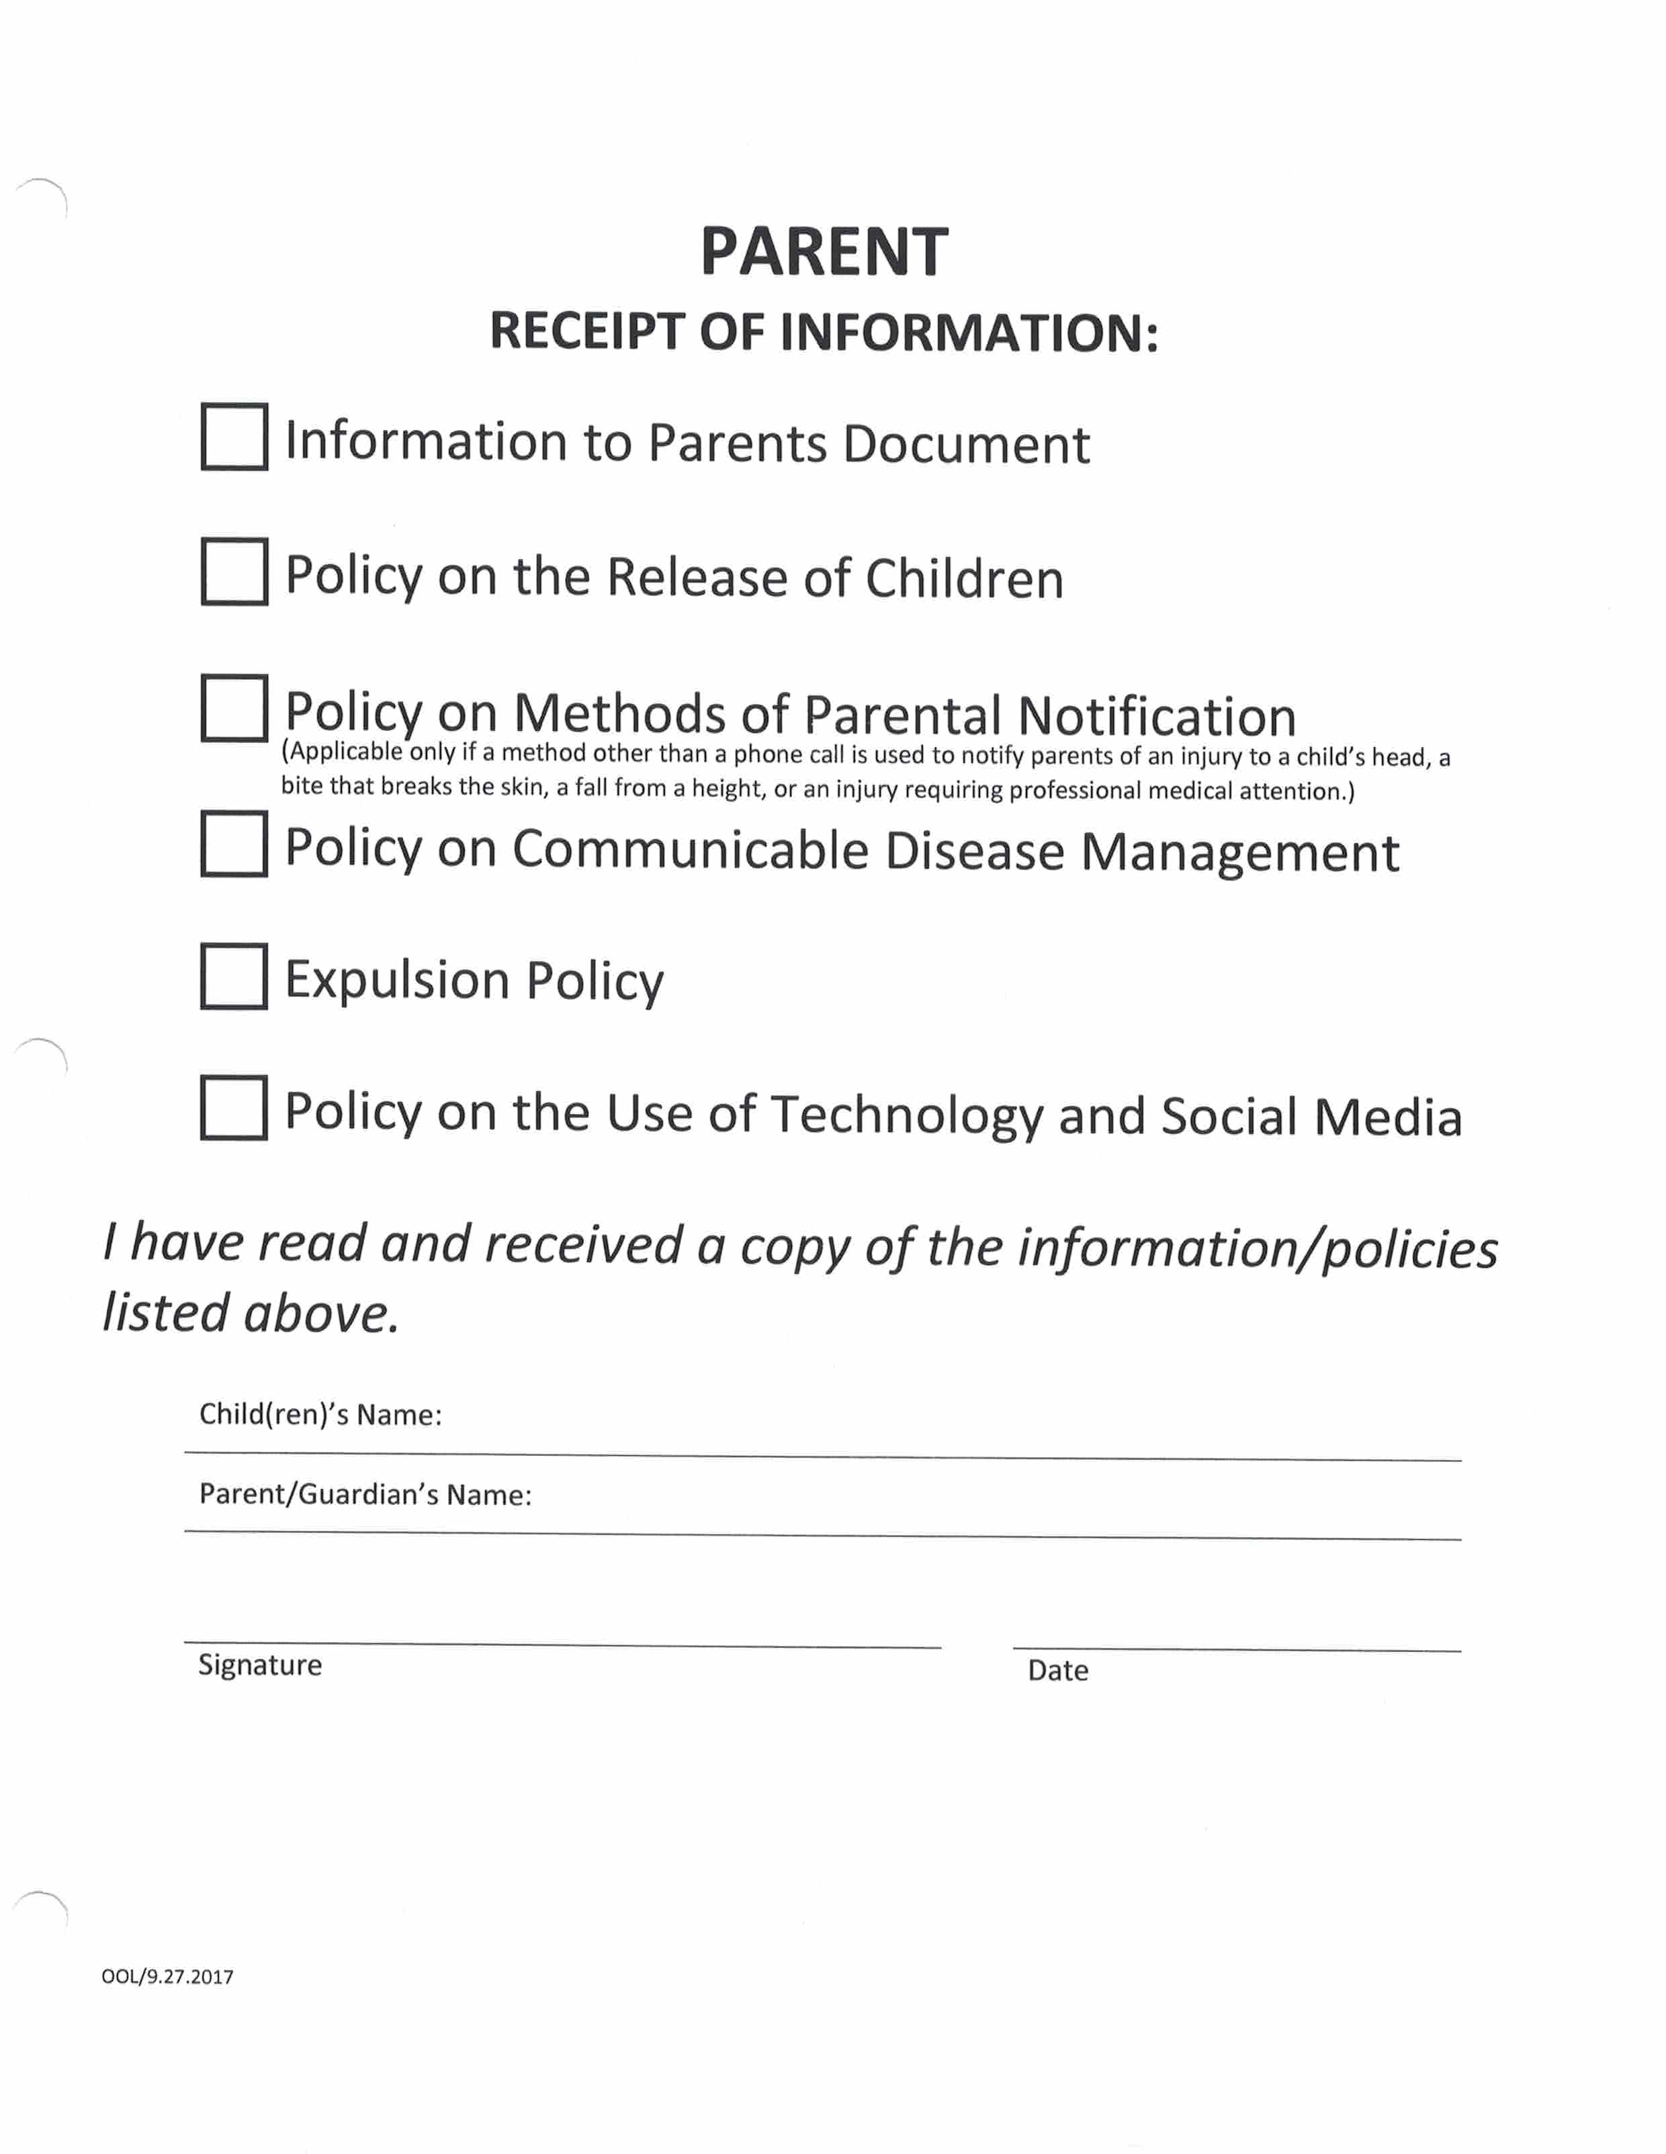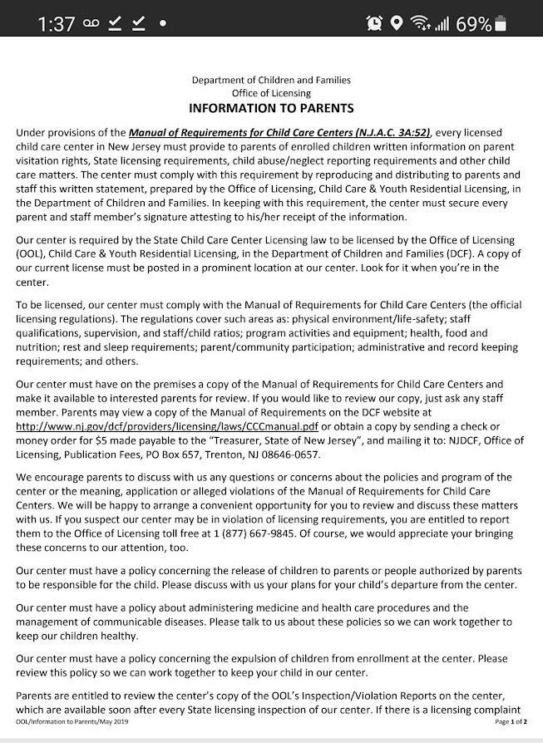

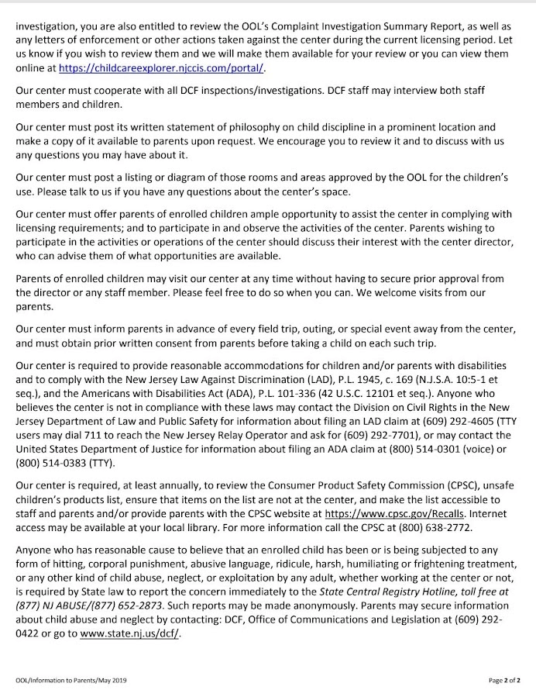

SIGN: _______________________________ DATE: ____________________
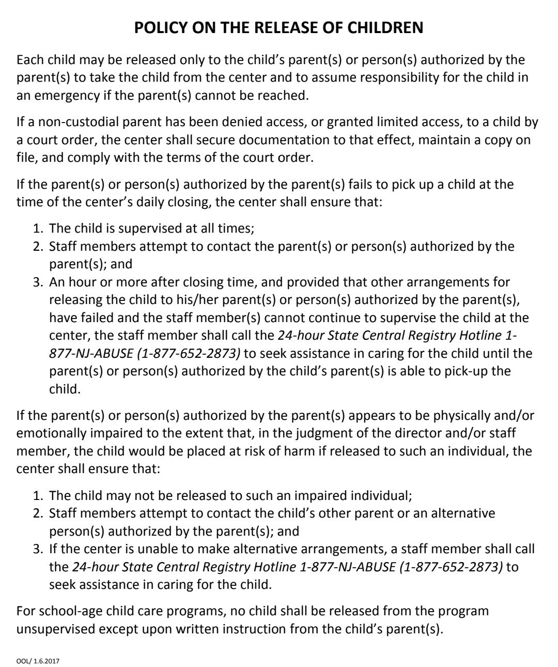

SIGN: _______________________________ DATE: ____________________
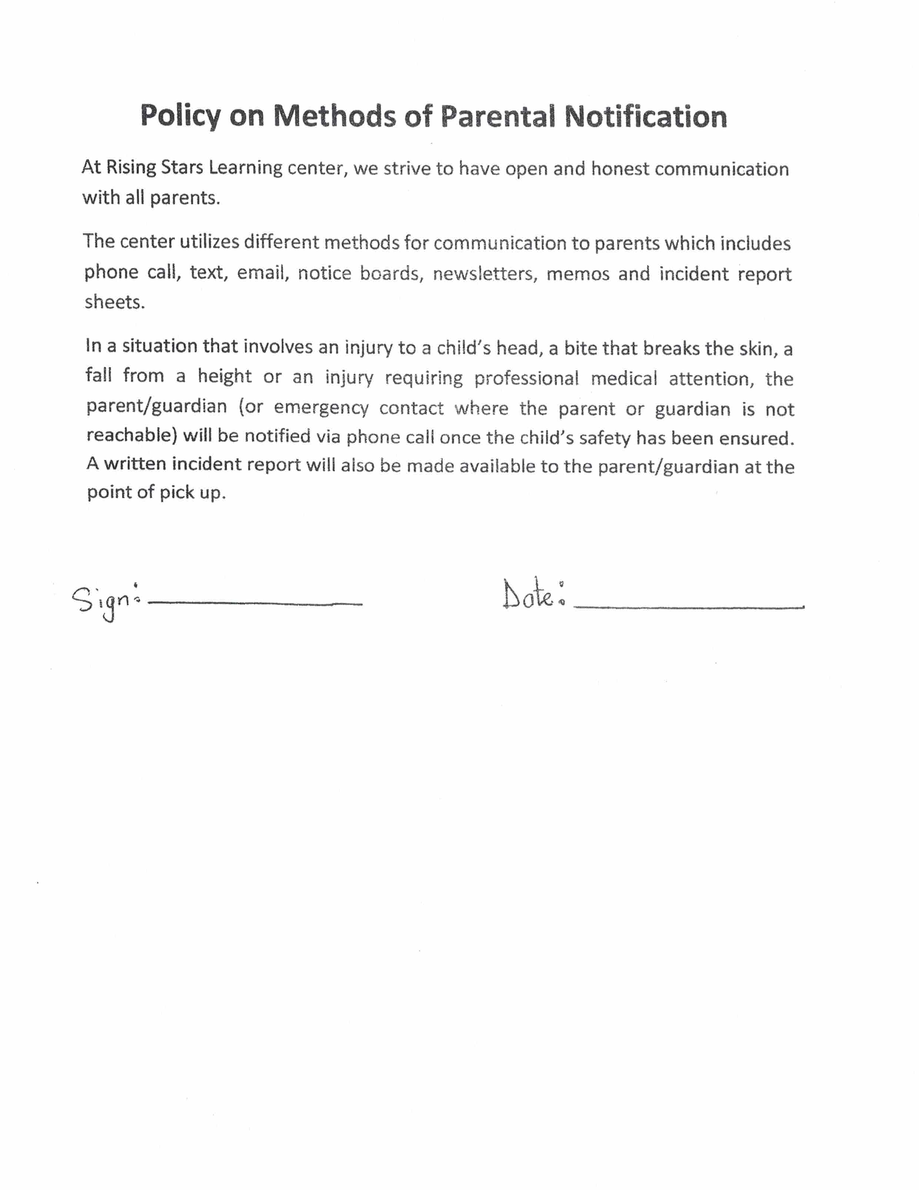

SIGN: _______________________________ DATE: ____________________
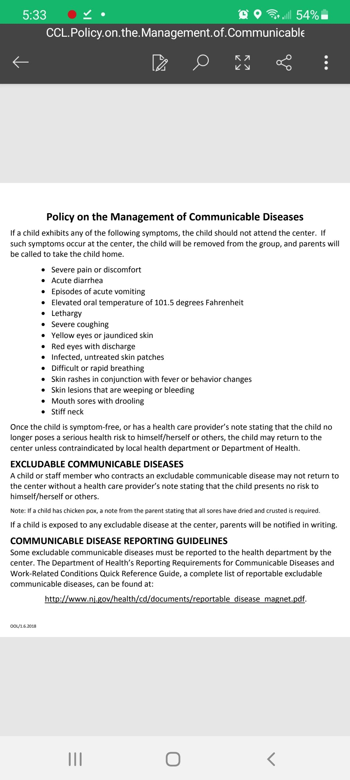

SIGN ______________________________ DATE ____________________________

EXPULSION POLICY
NAME OF CENTER: RISING STARS LEARNING CENTER
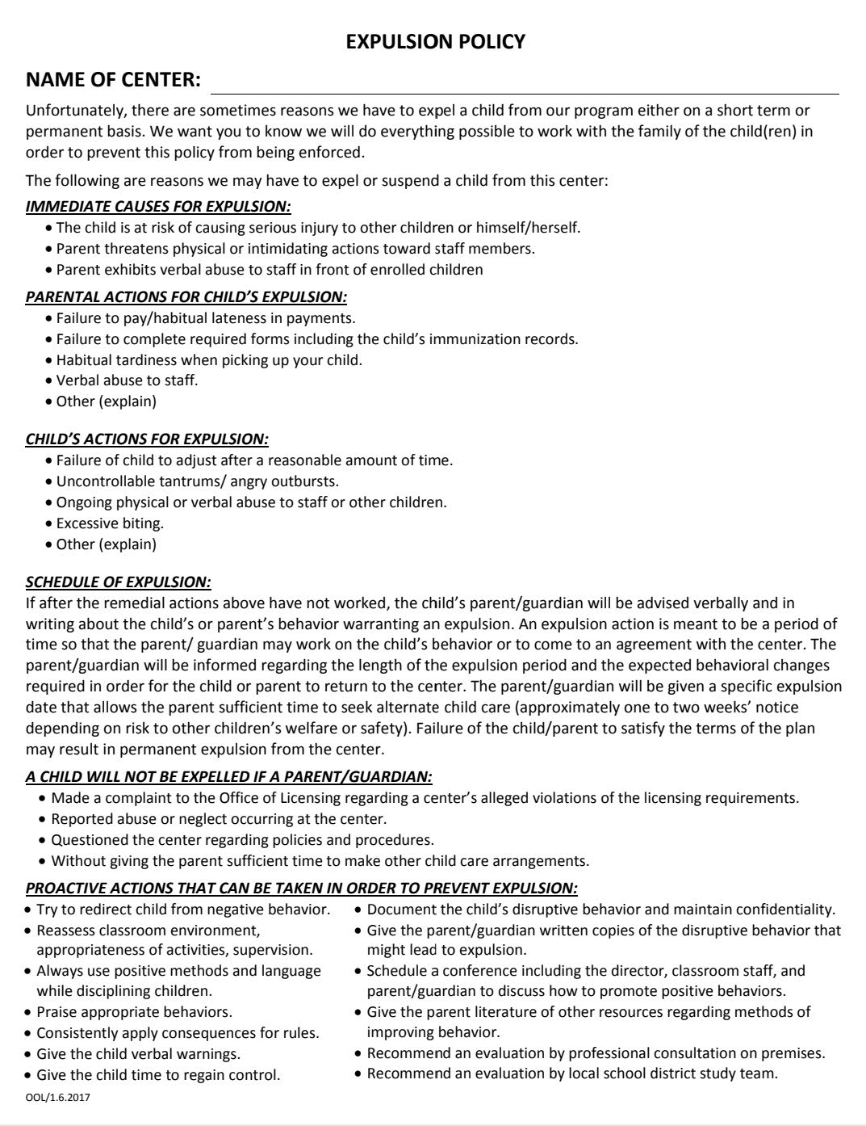

SIGN: ______________________________ DATE: ______________________

Policy on the Use of Technology and social media

Rising Stars Learning Center uses only the center owned devices to communicate with parents/guardians (i.e. computers and telephone). The center’s social media website is (rslc2009) and the Facebook page (Rising Stars Learning Center). Staff are not to use personal phones or email to communicate with families about the center’s business.

General center information/ updates on the center’s website can only be posted by the director.
Upon enrollment, every parent/guardian signs a photography consent form granting or declining permission for the child’s digital images to be taken and used by the center.

Parents can only take pictures and videos of their child in the classroom. Pictures that include other children cannot be taken, shared, or posted to social media sites. If there is a breach of this policy, it must be brought to the attention of the director immediately.

SIGN ______________________________ DATE ____________________________

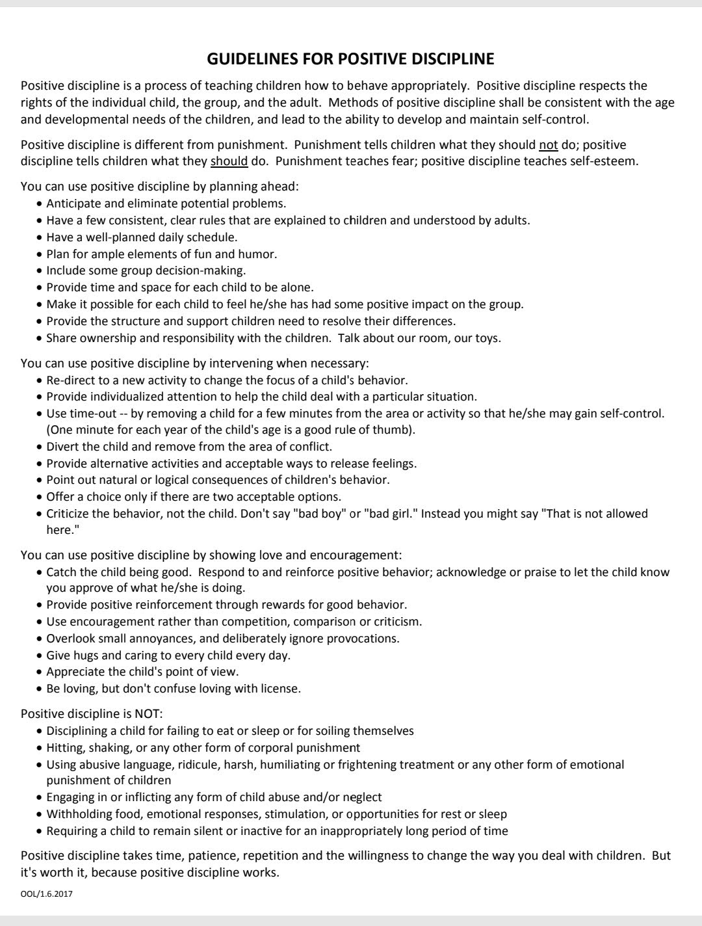

SIGN: _______________________________ DATE: ____________________
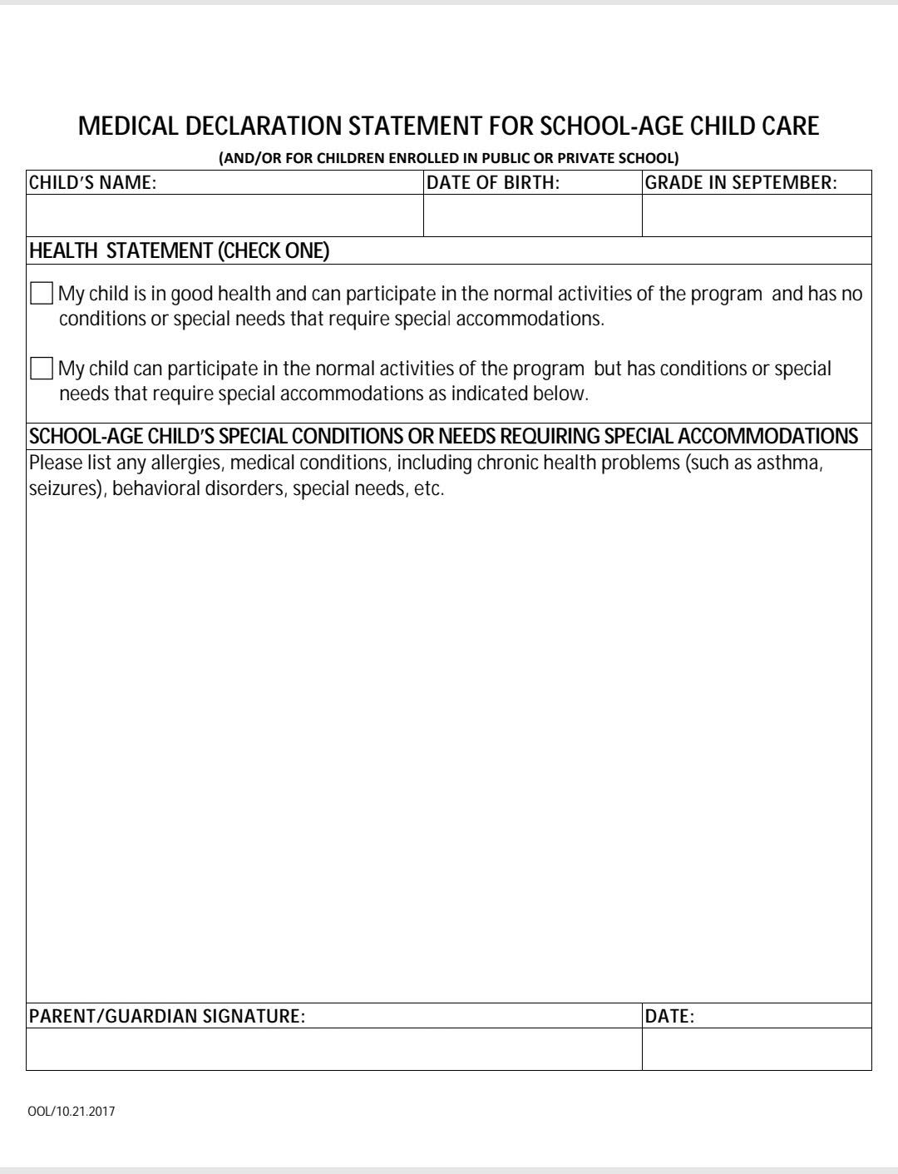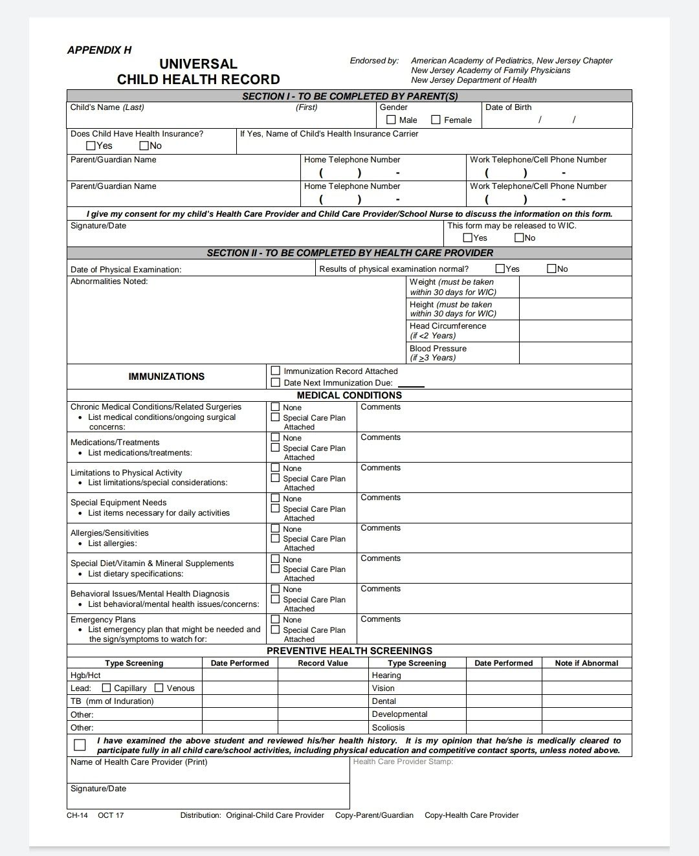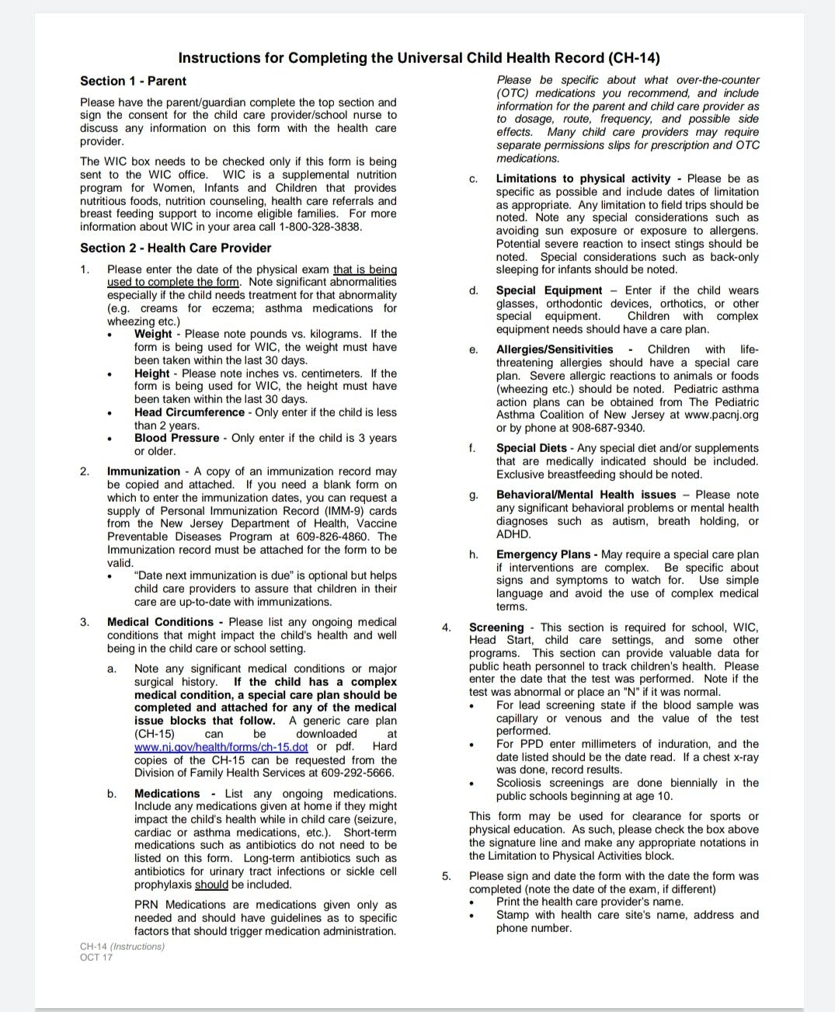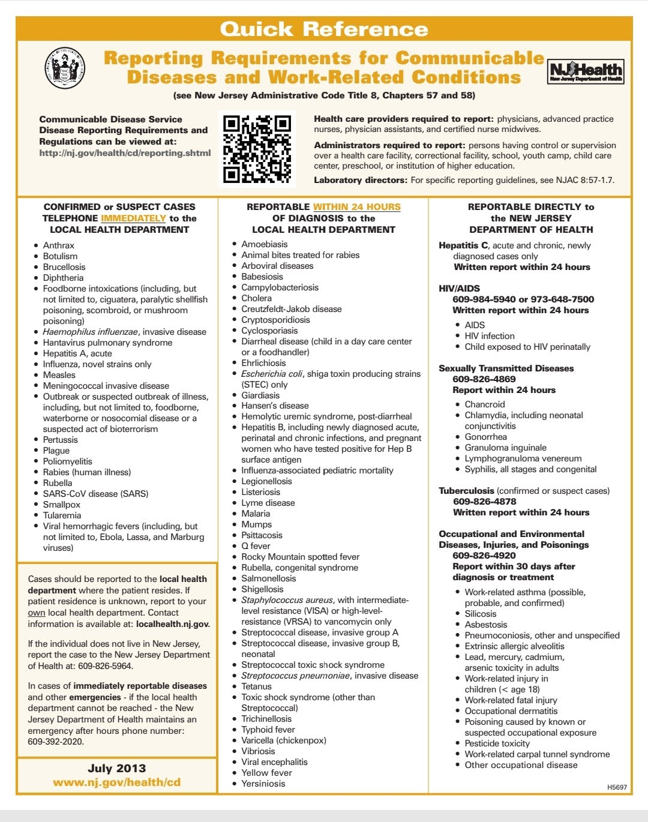
SIGN: _______________________________ DATE: ____________________

Rising Stars Learning Center
Photography Consent Form

Rising Stars Learning Center likes to celebrate your child’s work and achievements. Therefore, images of your child and his/her work may appear on our website, (risingstarslearning.com or facebook- Rising Stars Learning Center).

I_____________________________________________ parent/guardian
Of__________________________________________________
Hereby: grant permission/do not grant permission
To Rising Stars Learning Center to take and use my child's photographs and /or digital images for use in printed publications or material, electronic publications, school websites, and classroom displays for the duration of /her time here.

SIGNED: __________________________ DATE: _________________________
SIGNATURE OF PARENT/GUARDIAN

