
2026 Child Care Registration Form

CHILD’S INFORMATION

Child’s Full Name: ____________________________________ Birth Date: _____/_____/_____
Address: _____________________________________________ Home Phone: ________________
City: _____________________________ Prov./State: _________PC/Zip Code: ________________
Nickname: _______________________________

PARENT/GUARDIAN INFORMATION

Primary’s Full Name: ________________________________Home/Cell Phone: __________________
Address:__________________________________________________________________________
City: _____________________________ Prov./State: _________PC/Zip Code: ________________
Occupation: _____________________________ Work Phone: ____________________ext._______
Name of Employer________________________ Pager or Cellular Phone: ____________________
Business Address: __________________________________ City: ___________________________
Email address: ____________________________ Driver’s License # __________________________

Secondary’s Full Name: ______________________________ Home/Cell Phone: __________________
Address: __________________________________________________________________________
City: _____________________________ Prov./State: _________PC/Zip Code: ________________
Occupation: _____________________________ Work Phone: ____________________ext._______
Name of Employer________________________ Pager or Cellular Phone: ____________________
Business Address: __________________________________ City: ___________________________
Email Address: ____________________________

Parent/Guardian with legal custody _________________________________________________
Parents are: Married ___ Living Together___ Divorced ___ Separated ___ Widowed ___ Single ___
Other Household Members:
Names: _________________________________ Ages: _________ Relationships ________________
Names: _________________________________ Ages: _________ Relationships ________________
Names: _________________________________ Ages: _________ Relationships ________________

CHILD PICK-UP INFORMATION

Please list below the people who have *Permission* to pick up your child.
*Note: Anyone picking up your child must have a picture ID. Please let us know when someone else other than you picking up.

Name: __________________________ Phone: _________________ Relationship: __________
Name: __________________________ Phone: _________________ Relationship: __________
Name: __________________________ Phone: _________________ Relationship: __________

Please list those persons who *Do Not Have Permission* to pick up your child.
Please explain the reason below or talk to your caregiver so she is aware of the situation.

Name: __________________________ Phone: _________________ Relationship: __________
Name: __________________________ Phone: _________________ Relationship: __________

Reason person is not allowed to pick up your child:
Name: __________________________
Reason: ___________________________________________________________________________

Name: __________________________
Reason: ___________________________________________________________________________

EMERGENCY CONTACTS
Primary Emergency Contact (other than parents or guardian)
Name: ________________________________________________
Home/Cell Phone: _______________________________ Work Phone: ____________________________
Relationship to Child: ________________________________________________________________
Address:___________________________________________________________________________

Secondary Emergency Contact (other than parents or guardian) Name:________________________________________________
Home/Cell Phone: _______________________________ Work Phone: ____________________________
Relationship to Child: ________________________________________________________________
Address:___________________________________________________________________________

Any Special Instructions on how to reach parents: __________________________________________________________________________________
____________________________________________________________________________________________________________________________________________________________________

EMERGENCY INFORMATION
1. Child’s Physician: ________________________________ Phone: ___________________________
2. Preferred Hospital: _______________________________ Phone: ___________________________
3. Child’s Dentist: __________________________________ Phone: ___________________________
3. Insurance Company: ______________________________ Policy #: _________________________
4. Regular Medications: _______________________________________________________________
5. Blood Type: ______________________________________________________________________
6. Medicine allergic to: _______________________________________________________________
7. Food Allergies: ___________________________________________________________________
8. Any other Allergies: _______________________________________________________________
9. Immunization Record: Date of Last Immunization:_______________________________________
10. Any special health conditions: ______________________________________________________________________________________________________________________________________________________________________________________________________________________________________________________
11. Child has had: Child suffers from:
[ ] Measles [ ] Headaches
[ ] German Measles [ ] Earaches
[ ] Chicken Pox [ ] Sore Throat
[ ] Mumps [ ] Stomach Aches
[ ] Whooping Cough [ ] Flu / Colds
[ ] Other _____________ [ ] Other _____________

IMMUNIZATION RECORD

DPT 1. ___/___/___ 2. ___/___/___ 3. ___/___/___ 4. ___/___/___ 5. ___/___/___
Polio 1. ___/___/___ 2. ___/___/___ 3. ___/___/___ 4. ___/___/___ 5. ___/___/___
MMR ___/___/___ Measles ___/___/___ Mumps ___/___/___
Rubella ___/___/___ TB ___/___/___ HIV ___/___/___ HIB ___/___/___

OTHER IMPORTANT INFORMATION/PROVISIONS
The child will need special provisions such as:

[ ] Travel to and from school

[ ] Extracurricular activity [ ] Yes [ ] No
If yes, please give details: (what activity, when, if transportation is required, specific arrangements to attend with other family members/friends, etc.)
____________________________________________________________________________
____________________________________________________________________________

[ ] Other provisions we should be aware of: ___________________________________________
____________________________________________________________________________
____________________________________________________________________________

Do you have any outstanding concerns? __________________________________________________________________________________________________________________________________________________________

__________________________________________________________________

ALLERGIES & PRECAUTIONS

List any allergies, including food allergies, and any special precautions and/or treatment required for these allergies:
_______________________________________________________________________________________________________________________________________________________________________________________________________________________________________________________________

MEDICATIONS CURRENTLY BEING TAKEN

List medications, food supplements, or fluoride supplements being taken by your child:
_______________________________________________________________________________________________________________________________________________________________________________________________________________________________________________________________

ADDITIONAL MEDICAL INFORMATION

List any medical problem we should be aware of that may require special consideration or treatment
___________________________________________________________________________________________________________________________________________________________________________________
EMERGENCY RELEASE

Consent to Emergency First Aid & Transportation:

I, ____________________________ (parent/guardian), hereby grant my consent for
______________________________(child’s name), to be given emergency treatment by a staff member at the Rising Stars Learning Center childcare centre. I also give permission for my child to be transported by car or ambulance to an emergency centre for treatment, and agree to hold
Rising Stars Learning Center and its employees harmless.

Parent’s Signature ______________________________________ Date: ________________________

Consent to Medical Care and Treatment:

In the event that I cannot be contacted immediately during a medical emergency,
I, ____________________________ (parent/guardian), hereby grant my consent for
______________________________(child’s name), to be given emergency medical or surgical
treatment as prescribed by a treating physician, and hold Rising Stars Learning Center child care centre, and its employees harmless.

Parent’s Signature ______________________________________ Date: _______________________

Consent to Administer Medication:
Medications has to be unopen and sealed!

In the event that my child is ill, I, _________________________________ (parent/guardian), grant my consent for Rising Stars Learning Center childcare centre, to administer medication to
______________________________ (child’s name), as prescribed by a treating physician or by me, the parent, for over-the-counter medications as follows:
Name of Medication: ________________________ Date to begin: _____________ End: ____________
Amount of dose: ___________________________ Times to be given: __________________________
Additional Instructions: _______________________________________________________________
Possible side effects: _________________________________________________________________
Dr’s Signature_______________________________________ Date: _______________________
Parent’s Signature ____________________________________ Date: _______________________

Rising Stars Learning Center
Child Care Contract

This agreement between the Rising Stars Learning Center, here in after "PROVIDER", who will provide child care services in the facility located at 201 Veterans Parkway /201 Sunset Ave Willingboro, New Jersey 08046, and Parents ______________________________________________ hereinafter "PARENT(S)", who’s child/children _____________________________________________________________ hereinafter "CHILD", will attend that care.
Both parties acknowledge that they have read and understand the Policies & Procedures Handbook developed by Rising Stars Learning Center and that both parties agree to abide by the provisions and terms of this document.
The PROVIDER agrees that services will:
- provide childcare from 8 am start time to 5:30 pm (finish time) and begins on __________ through to _____________. Early care is a $25 additional charge from 6 am to 7:59 am. (Completion date if known, reviewed on an annual basis), for the weekdays of: [ ]M [ ]T [ ]W [ ]TH [ ]F, except on recognized federal holidays and PROVIDER holidays when the facility will be closed.
- feed the CHILD/CHILDREN, once in our care daily with one breakfast, one lunch, and one snack per day if the child is full-time, or one breakfast/lunch and one snack for part-day services, or one snack only for drop-in children, with such meals complying with Canadian/U.S.D. A nutritional guideline
- Provide daily activities and learning materials that entertain, educate, and develop the CHILD.
- Provide the items necessary to care for the CHILD with regard to personal hygiene, safety, and general day-to-day necessities.
- Provide facility name, address, and taxpayer identification number for the PARENT to use to qualify for Child Care Credit when submitting their income tax.

The PARENT(S) agree that they will:
- Drop off and pick up their CHILD within the times set above or pay an overtime fee as agreed to below. The PARENT(S) will provide reasonable notice to the PROVIDER if they will be late in picking up their child.
- Inform the PROVIDER of illness, communicable disease, or problems with their CHILD that could affect other children in the care of the PROVIDER and keep the CHILD home when presenting any of the signs of illness as outlined in the Policies & Procedures Parent Handbook.
Complete the Registration, Child Development, Emergency Medical Information, and Permission Forms.
- Supply the PROVIDER with the following items necessary for the care of their CHILD:
[ ] Diapers [ ] Special Diet Foods [ ] Wipes [ ] Blanket, Sheet, Pillow Case
[ ] Other items such as ______________.
- Ensure that the child's immunizations are kept up to date and provide the immunization information and physician’s signature as required by state regulations.
- Comply with all requirements and policies of Rising Stars Learning Center.
The parties agree that in exchange for these childcare services, the PARENT(S) will pay the PROVIDER the following fees:
- A $ 100.00 registration fee per child is due upon the signing and execution of this agreement, a set fee will cover any materials needed to enroll your child/children.
- $____________ per [ ]Week, [ ]Day, [ ]Hour, as a flat rate for the times set above, due and payable not later than the beginning of the last day of care for each [ ]Week, [ ]Bi-Week,
[ ]Month, [ ]Day.
- $ 25.00 per week late fee if the rate is not paid on time.

- $20 per week for Transportation fee in addition to Before and Aftercare & Before or After Care tuition.
- $ 15.00 per quarter hour or any fraction of an hour, if the PARENT(S) fails to pick up the CHILD by the times, stated above, due and payable upon the arrival of the PARENT(S) responsible for picking up the child.
- PARENT(S) agrees to pay the PROVIDER one week’s tuition before services.
- If the Parent or Guardian receives State or Government Tuition assistance for the child/children, then the weekly co-pay must be paid by Friday for the upcoming week. If the co-pay is not paid and your child’s account becomes delinquent, Rising Stars Learning Center will report such action to the issuing agency. Termination of care for the child/children will cease at that time.

The parties agree that all such payments shall be made in CASH, CASHAPP, ZELLE, or MONEY ORDER.
PARENT(S) agree to pay the PROVIDER $______________________, equivalent to (one-half (1/2) of the agreed fees), for one time their family is on vacation and one sick time to retain a day-care slot for the CHILD or if the CHILD is out due to illness or family emergencies. Full tuition is required afterward and if your child is willingly kept at home.
Both parties agree that if other arrangements are made for childcare during the time when the CHILD is under contract to be cared for with the PROVIDER, the PARENT(S) will pay for the service regardless of whether or not their child attended Rising Stars Learning Center.
Both parties agree that a two-week written notice must be served to the respective party should either the PARENT or the PROVIDER decide to terminate this agreement. If the two weeks written notice is not provided, the PARENT will be responsible for paying the agreed-upon fees in absence of notice or a portion thereof if some notice is given, and the PROVIDER agrees to reimburse the parent for any already paid services of the same.
This contract is subject to a yearly review on _____/_____/________. Parents will be given a month’s notice if changes with regard to fees, hours of care, and/or terms of care are made by the PROVIDER.
Both parties agree to the following miscellaneous provisions: ____________________________________________________________________________________________________________________________________________________________________________________________________________________________________________________________________________________________________________________________________________________This contract is legally binding on both parties and subject to enforcement through any lawful means. Any party in default is liable for attorney fees, court costs, and any other expenses incurred in enforcement, if applicable.
Understood, agrees to, and signed this ________ day of __________, 20___.
____________________ ___________________ __________________
(Facility Operator) (Signature) (Date)
_____________________ ___________________ __________________
(Mother/Guardian) (Signature) (Date)
_____________________ ___________________ __________________
(Father) (Signature) (Date)

CHILD DEVELOPMENT FORM

Child's Name: _________________________________________
Preferred Name: ________________________________________
Age: _____________

In order for me to provide quality care for your child, I need to understand a bit about his/her developmental history. Feel free to write in as much information as you like. Use the reverse side of this form if necessary.

ACTIVITIES:
Please list your child's favorite toys and activities.
____________________________________________________________________________________________________________________________________________________________________
__________________________________________________________________________________
What do you consider your child’s activity level to be like:
[ ] Normal [ ] Tends to get a bit hyper [ ] Prefers reading and quiet activities to outdoor play [ ] Prefers to be outside

HEALTH:
Does your child suffer from food allergies or insect bites? [ ] YES [ ] NO
If yes, please explain what needs to be done in these instances:
________________________________________________________________________________________________________________________________________________________
Is there any thing I should know about your child's physical or mental health? [ ] YES [ ] NO
If yes, please elaborate:
____________________________________________________________________________
____________________________________________________________________________
____________________________________________________________________________
Has your child been hospitalized? Explain: _______________________________________________
Has your child had any injuries with fractures or loss of consciousness? Explain: __________________________________________________________________________________
Last immunization date: _____________________ Proof: __________________________________
Last vision test date: ________________________ Last hearing test date: ______________________
Last dentist visit date: _______________________ Last physical examination: __________________
Last Flu shot:_______________
Do any members of your family have a history of: Asthma _____ Diabetes ______ Epilepsy ______

Does your child have problems with: (circle all that apply)
Constipation Convulsions Diarrhea Fainting Spells Frequent Colds

Skin Rash Ring Worm Lice Stomach Upsets Sore Throats
Worms Ear Infections Soiling

Has your child had any of these diseases: (circle all that apply)
Asthma Bronchitis Diabetes Chicken Pox German Measles
Measles Mumps Hepatitis Impetigo Heart Disease
Scarlet Fever Tuberculosis Polio Whopping Cough

SLEEPING HABITS:
Does your child nap? [ ] YES [ ] NO
Do you keep your child on a regular nap-time schedule? [ ] YES [ ] NO
At what time does he/she generally like to sleep? _____________________
Does your child have a favorite toy, blanket, etc. he/she likes to sleep with? [ ] YES [ ] NO
If yes, please elaborate: ________________________________________________________
What is your child’s temperament when he/she wakes up? ___________________________________
____________________________________________________________________________

TOILET HABITS:
Is your child toilet trained? [ ] YES [ ] NO
What word does your family use for urination? ____________________
For bowel movements? ____________________
Does your child have accidents? [ ] YES [ ] NO
If yes, please explain how you handle this: _______________________________________
__________________________________________________________________________
Does your child wear diaper during nap times? [ ] YES [ ] NO

SOCIAL DEVELOPMENT:
Is your child used to playing with other children? [ ] YES [ ] NO Does your child have trouble separating from you when being dropped off? [ ] YES [ ] NO
If yes, what do you do to assist your child? _________________________________________
____________________________________________________________________________
Does your child make shy or have trouble adjusting to new places and faces? [ ] YES [ ] NO
If yes, how do you assist your child?_______________________________________________ ____________________________________________________________________________
Does your child have a tendency to run away? [ ] YES [ ] NO
How does your child express anger or frustration? _________________________________________
Does your child have a tendency to throw temper tantrums? [ ] YES [ ] NO
If yes, how do you handle this?___________________________________________________
____________________________________________________________________________
When your child is upset, what do you do to comfort him/her? ________________________________
Does your child have any special fears? __________________________________________________

What method of discipline do you use with your child?

Is there anything you are concerned about where your child's social development is concerned?
[ ] YES [ ] NO
If yes, please elaborate: ________________________________________________________
____________________________________________________________________________
____________________________________________________________________________
Are there any development concerns, diagnosed or suspected with your child (i.e.: advances, slow)?
[ ] YES [ ] NO
If yes, what are the recommendations for working with your child? ______________________
____________________________________________________________________________
____________________________________________________________________________

LAUNGUAGE DEVELOPMENT:
Is your child using words? [ ] YES [ ] NO
Does your child speak in sentences? [ ] YES [ ] NO
Is a second language spoken in your home? [ ] YES [ ] NO What language?__________________
Does your child have difficulty with his/her speech? [ ] YES [ ] NO
If yes, please elaborate:_________________________________________________________
________________________________________________________________________________________________________________________________________________________

FOODS:
What foods does your child like? _______________________________________________________
____________________________________________________________________________
What foods does your child dislike? _____________________________________________________
____________________________________________________________________________
What do you do when your child refuses to eat? ___________________________________________
____________________________________________________________________________
What drinks does your child prefer? _____________________________________________________
Is your child drink a lot of liquids? [ ] YES [ ] NO
Do you water down fruit juices? [ ] YES [ ] NO

ADJUSTMENT:
Do you expect any adjustment problems when your child begins care? Explain:
____________________________________________________________________________
____________________________________________________________________________
Previous child care attended: __________________________________________________________
Any problems at previous child care: ____________________________________________________
FAMILY LIFE:
Can you please tell me who else lives at home with you and your child?
Name:_________________________ Nick Name:__________________ Relationship:_____________
Name:_________________________ Nick Name:__________________ Relationship:_____________ Name:_________________________ Nick Name:__________________ Relationship:_____________
Please note here any special family concerns I should be aware of such as custody arrangements or other family situations. _______________________________________________________________
____________________________________________________________________________
OTHER INFORMATION:
Please tell me anything else you would like me to know about your child (his/her general personality, tendency towards affection, etc.).
______________________________________________________________________________________________________________________________________________________________________________________________________________________________________________________________________________________________________________________________________________________________________________________________________________________________________________________________________________________________________________________________________________________________________________________________________________________________________________________________________________________________________________________________________________________________________________________________________________________________________________________________________________________________________________________________________

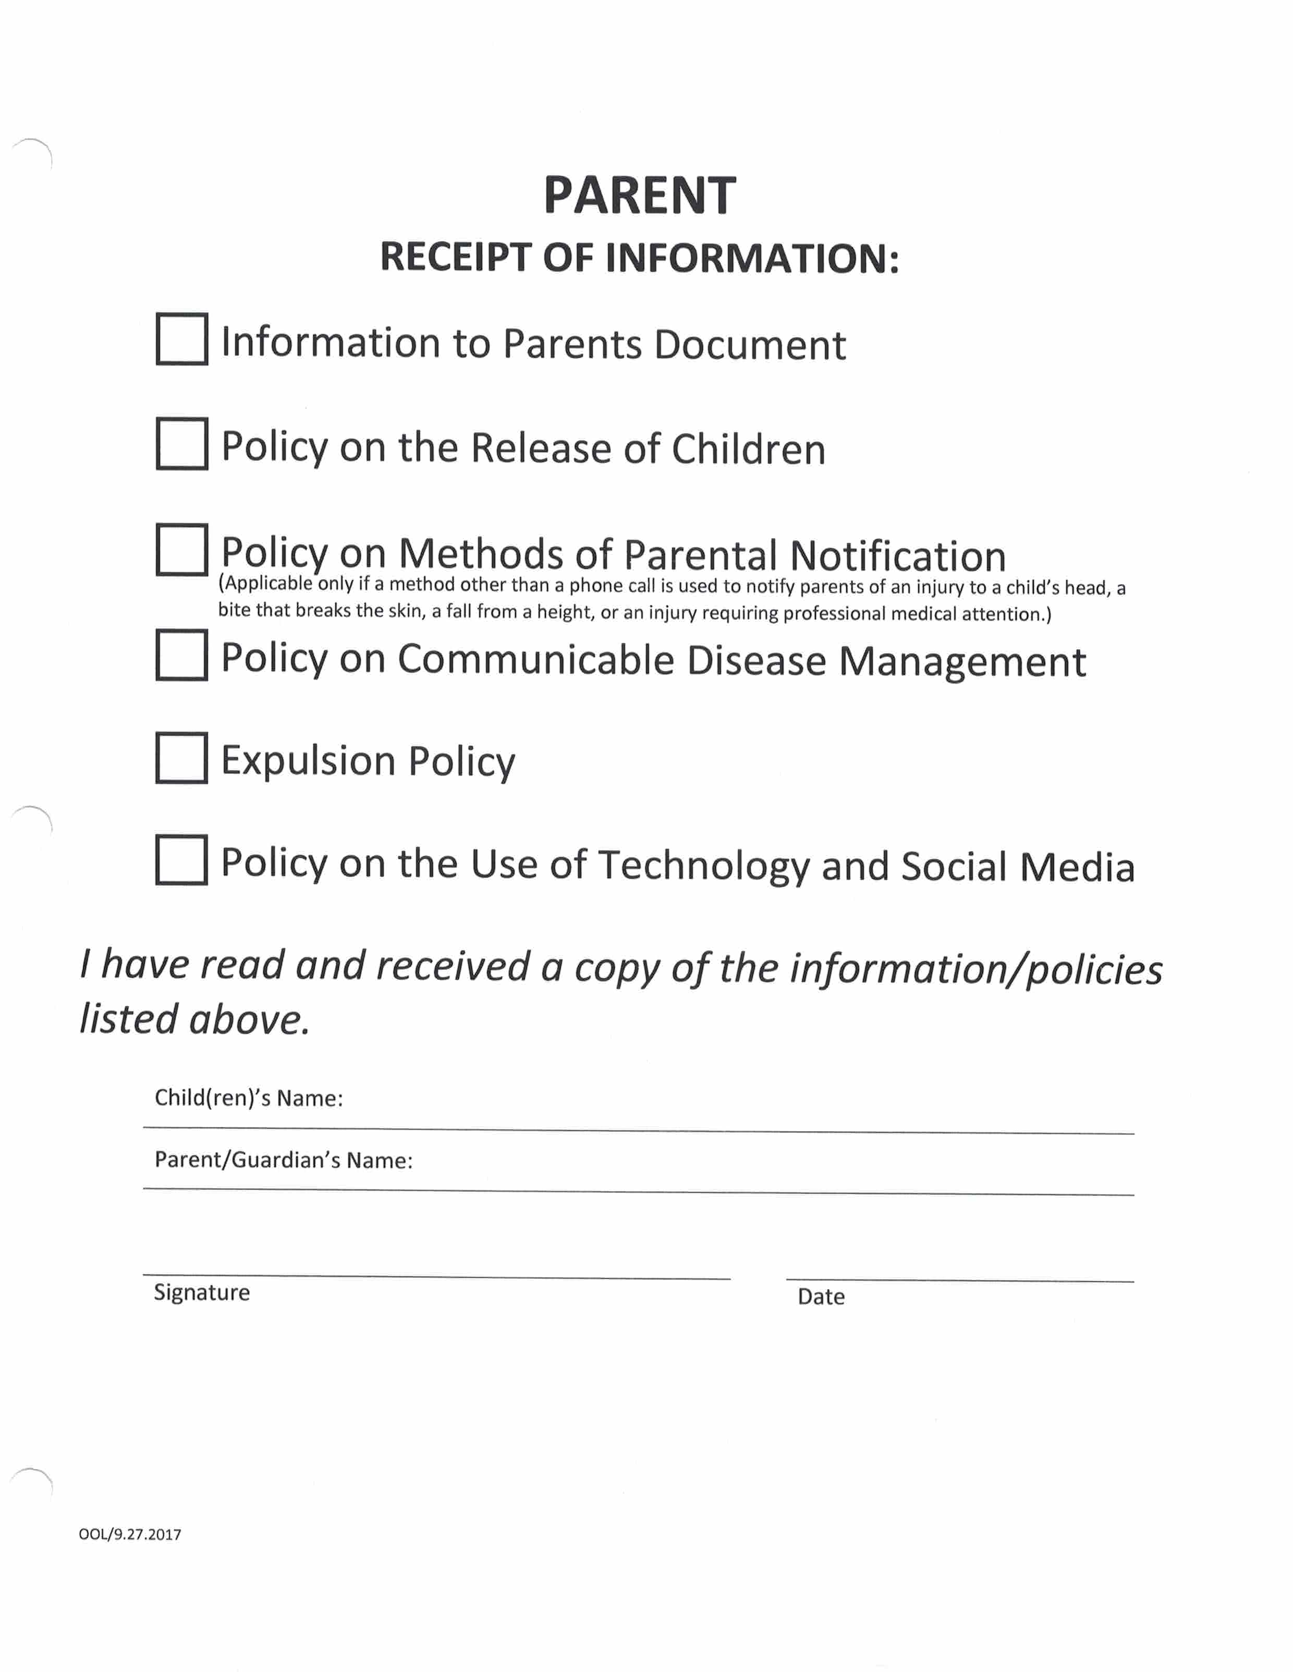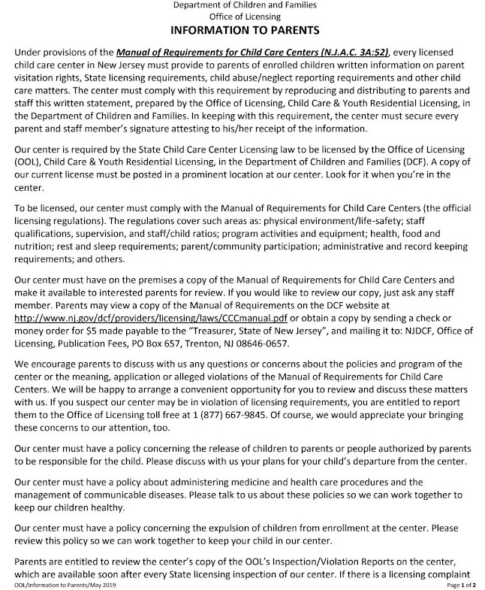

SIGN: _______________________________ DATE: ____________________

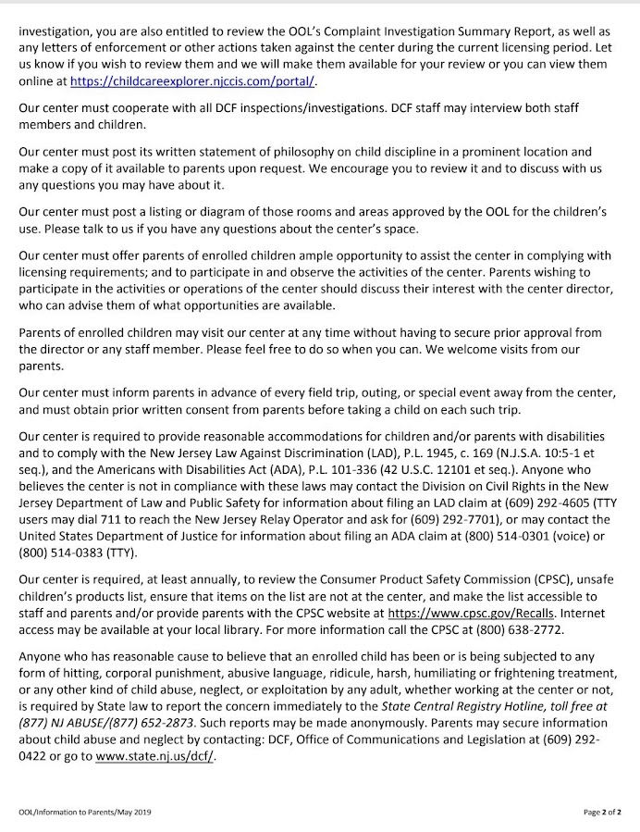

SIGN: _______________________________ DATE: ____________________
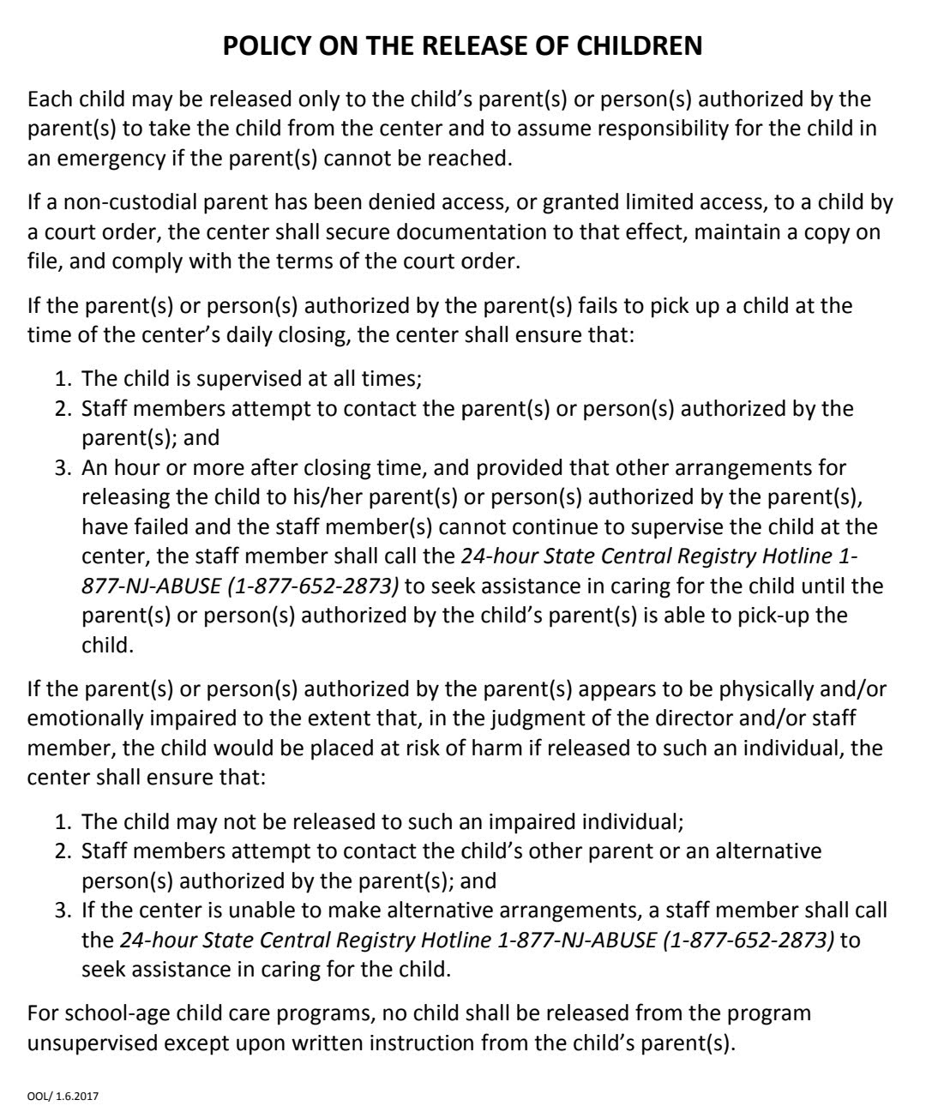

SIGN: _______________________________ DATE: ____________________

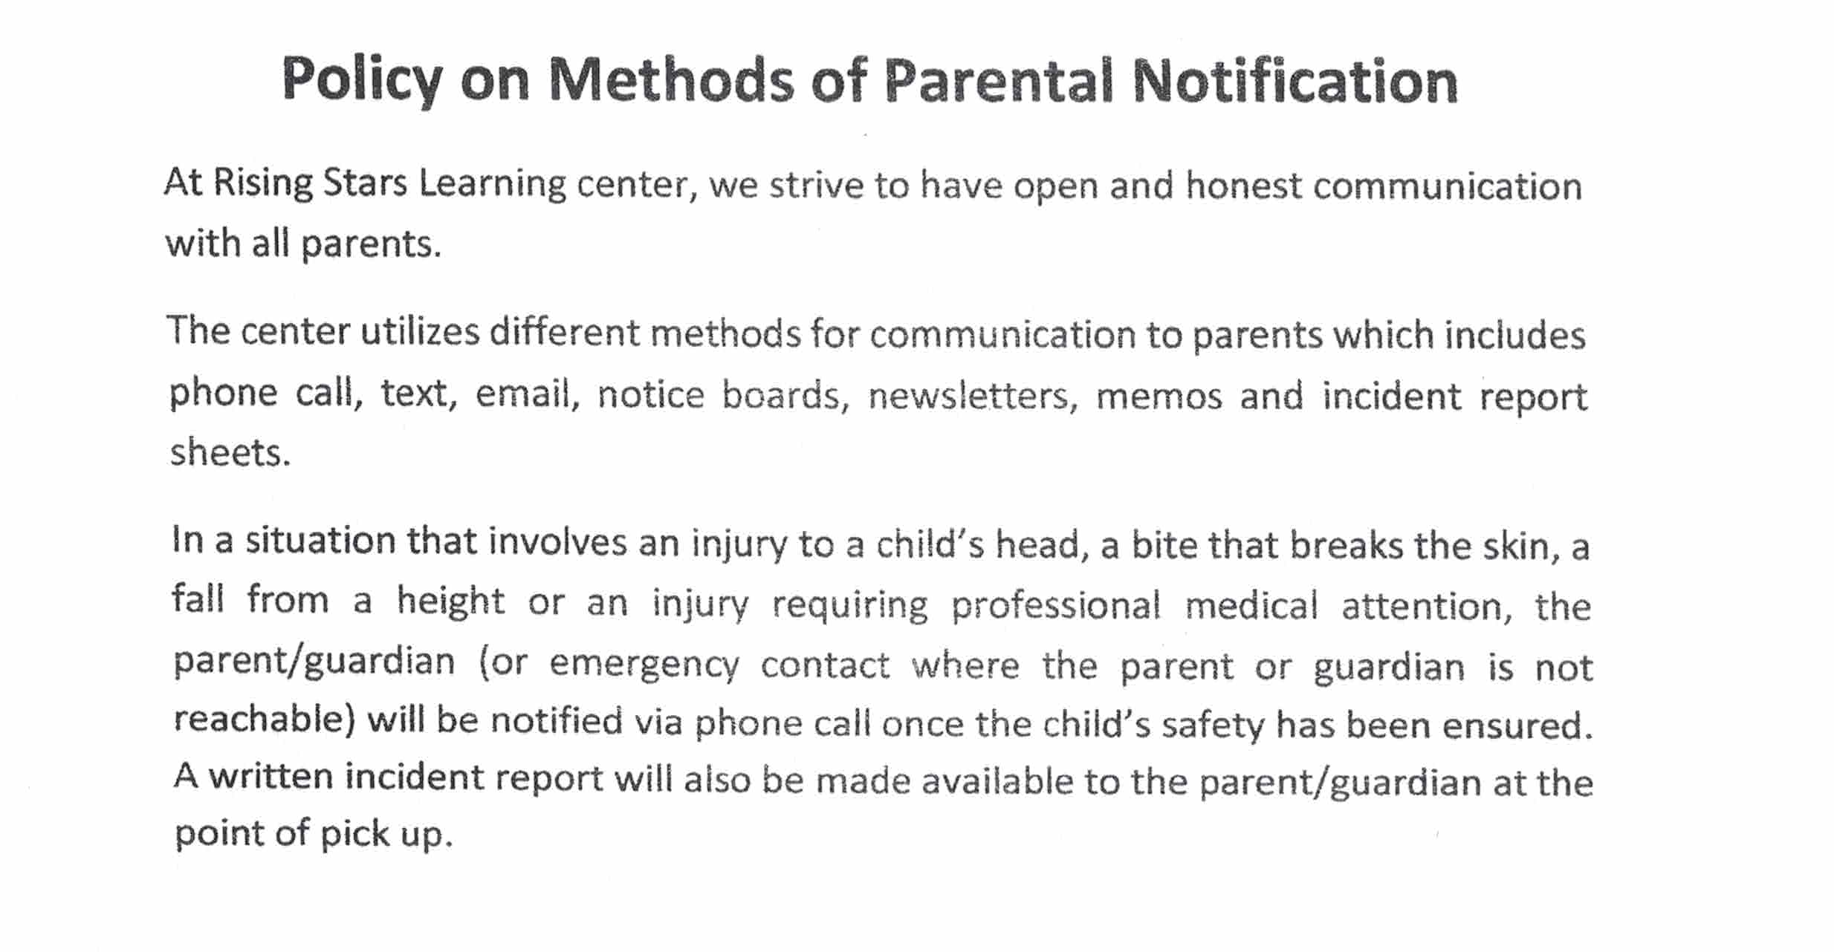

SIGN: _______________________________ DATE: ____________________
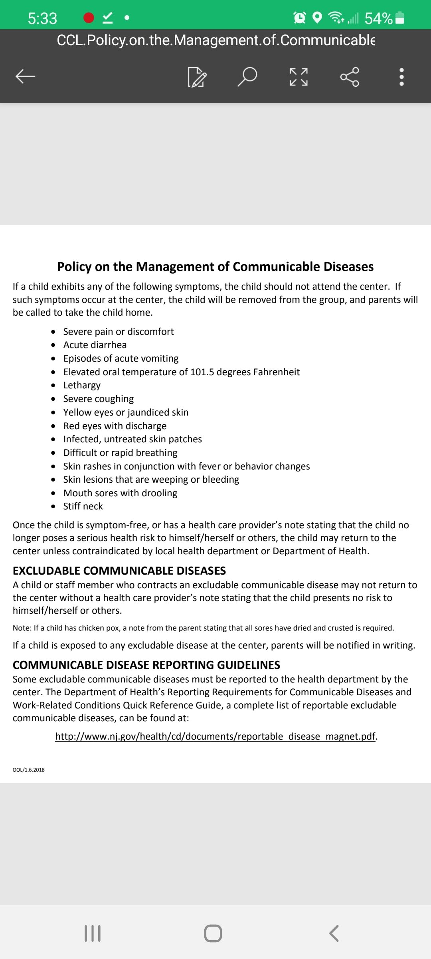

SIGN ______________________________ DATE ____________________________

EXPULSION POLICY
NAME OF CENTER: RISING STARS LEARNING CENTER

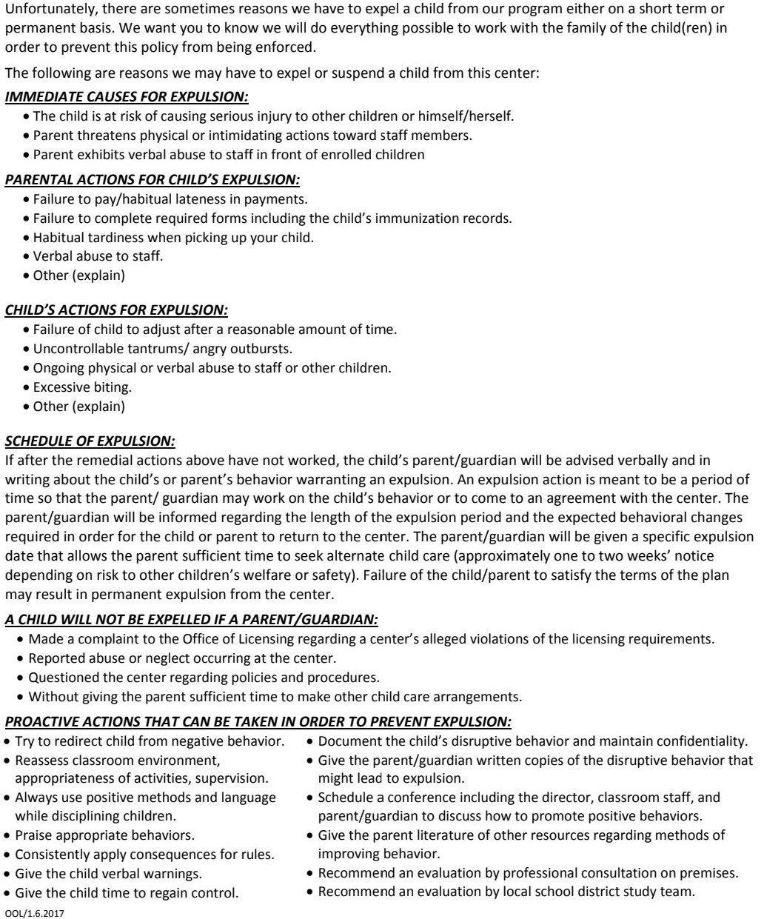

SIGN: ______________________________ DATE: ______________________

Policy on the Use of Technology and social media

Rising Stars Learning Center uses only the center owned devices to communicate with parents/guardians (i.e. computers and telephone). The center’s social media website is (rslc2009) and the Facebook page (Rising Stars Learning Center). Staff are not to use personal phones or email to communicate with families about the center’s business.

General center information/ updates on the center’s website can only be posted by the director.
Upon enrollment, every parent/guardian signs a photography consent form granting or declining permission for the child’s digital images to be taken and used by the center.

Parents can only take pictures and videos of their child in the classroom. Pictures that include other children cannot be taken, shared, or posted to social media sites. If there is a breach of this policy, it must be brought to the attention of the director immediately.

SIGN ______________________________ DATE ____________________________

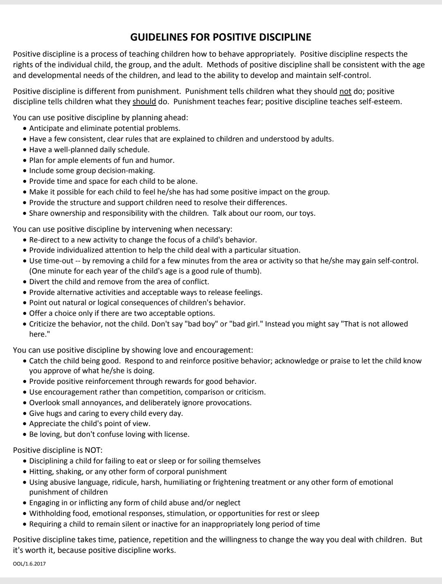

SIGN: _______________________________ DATE: ____________________

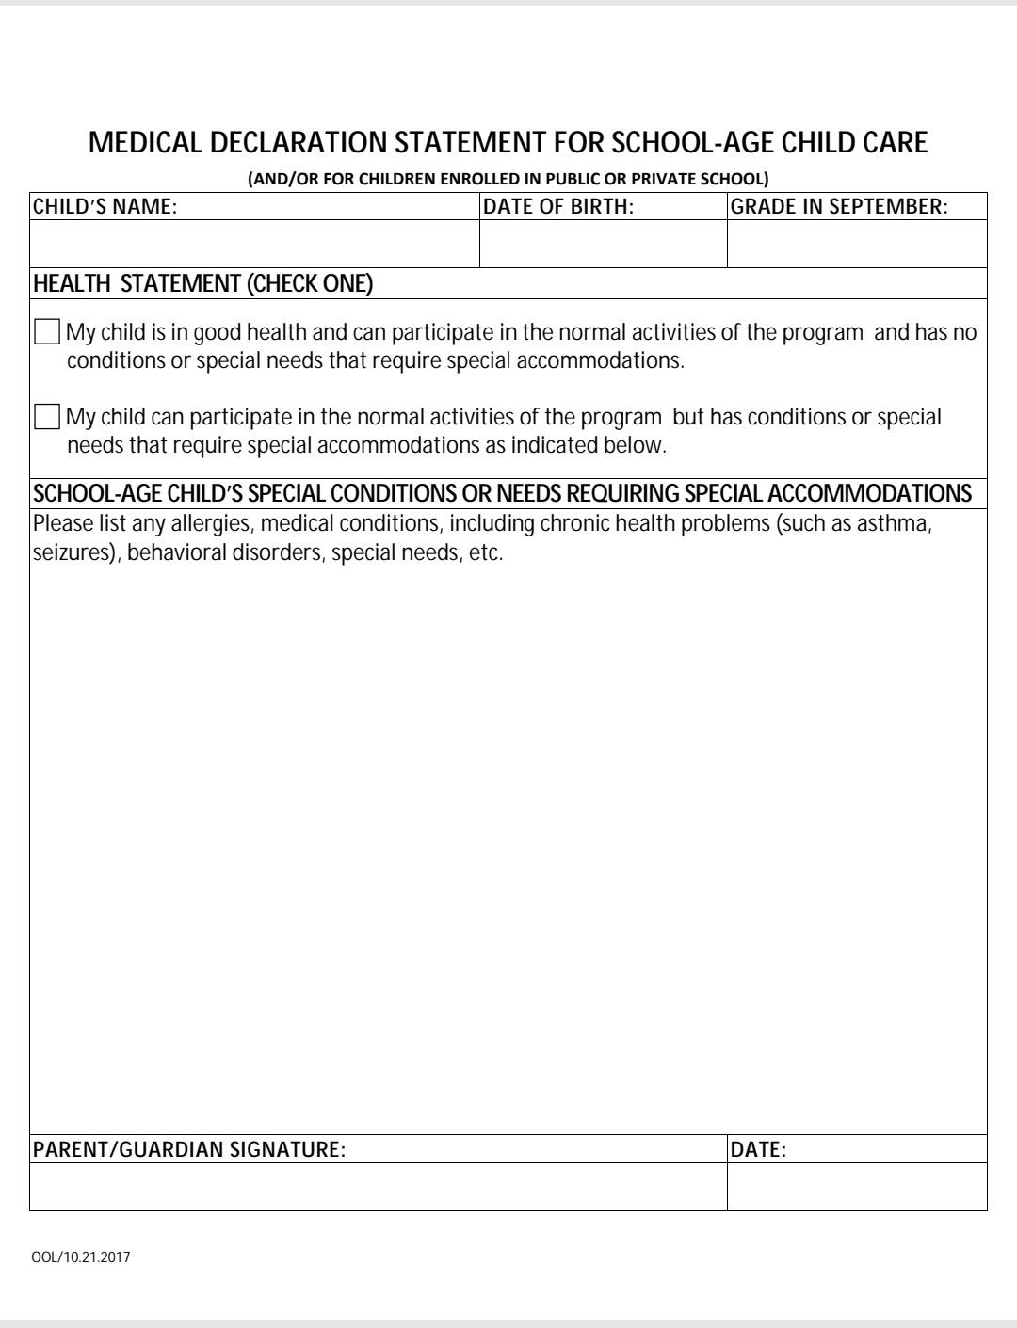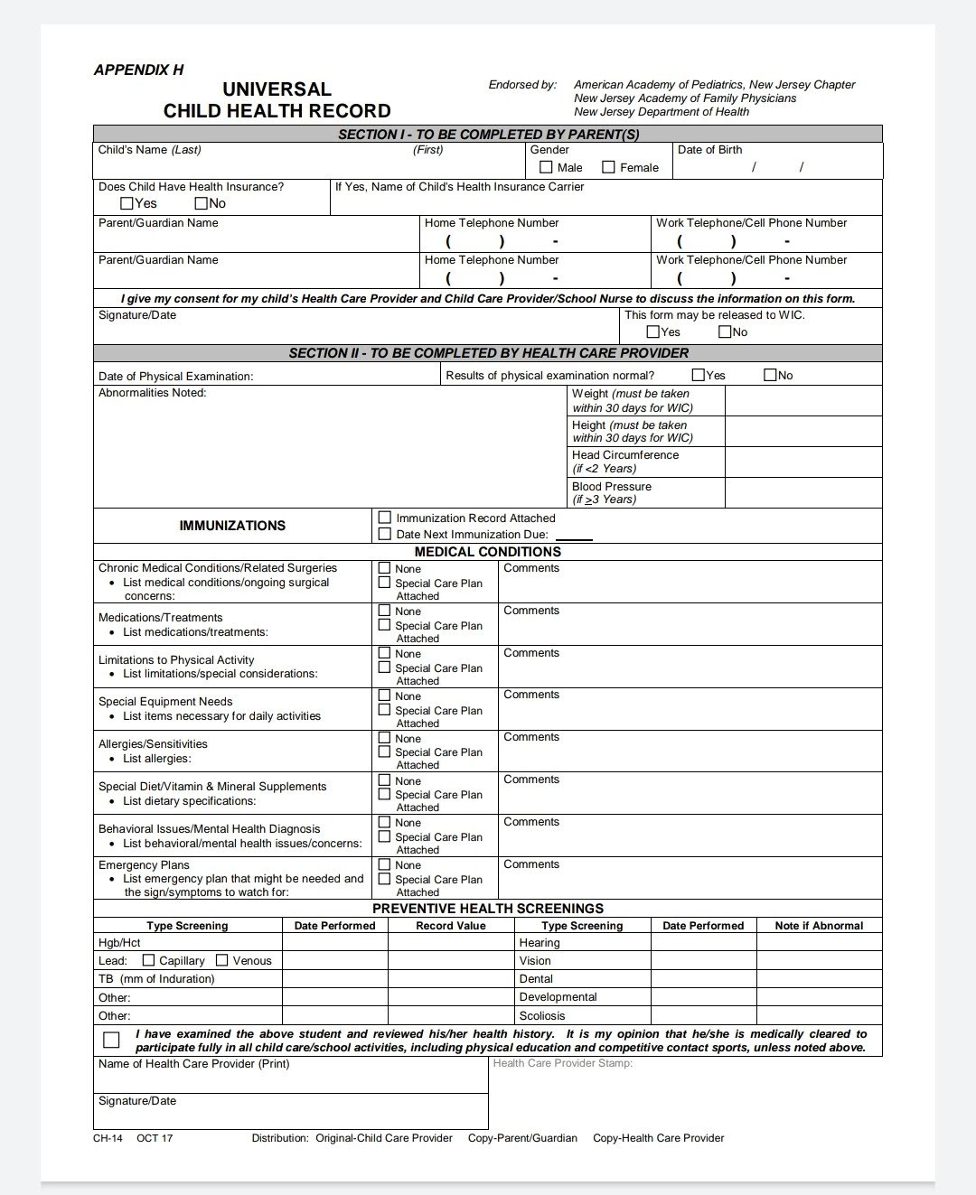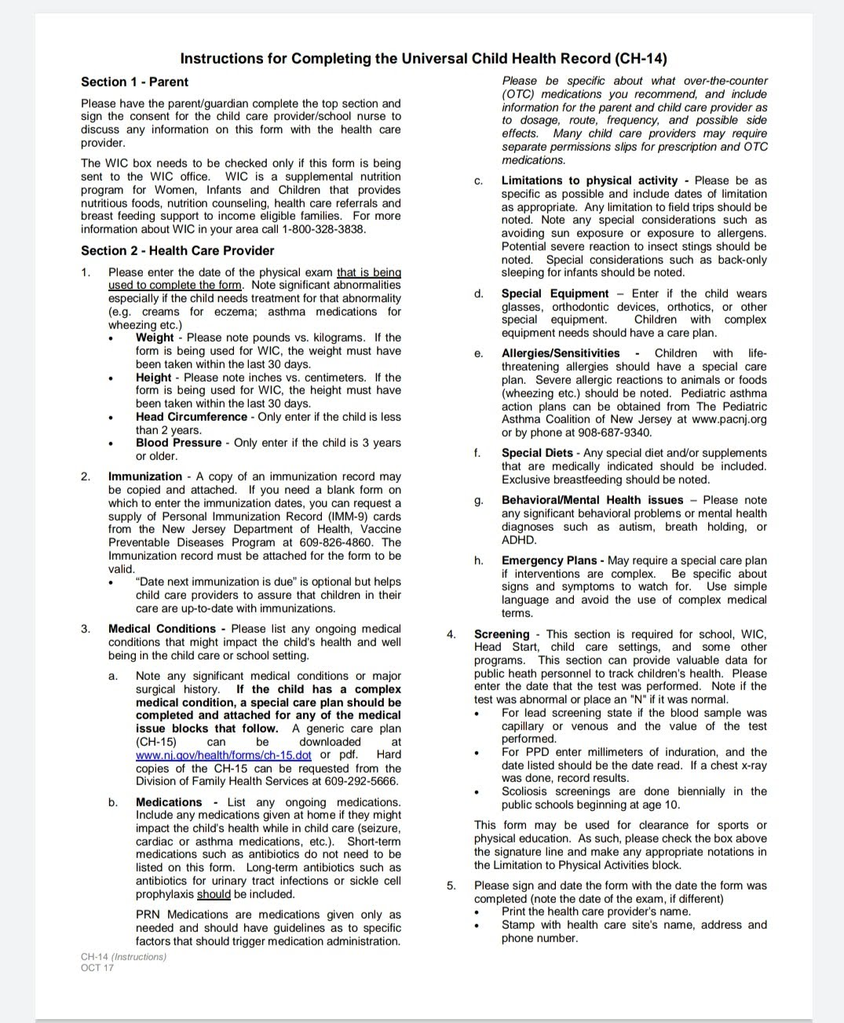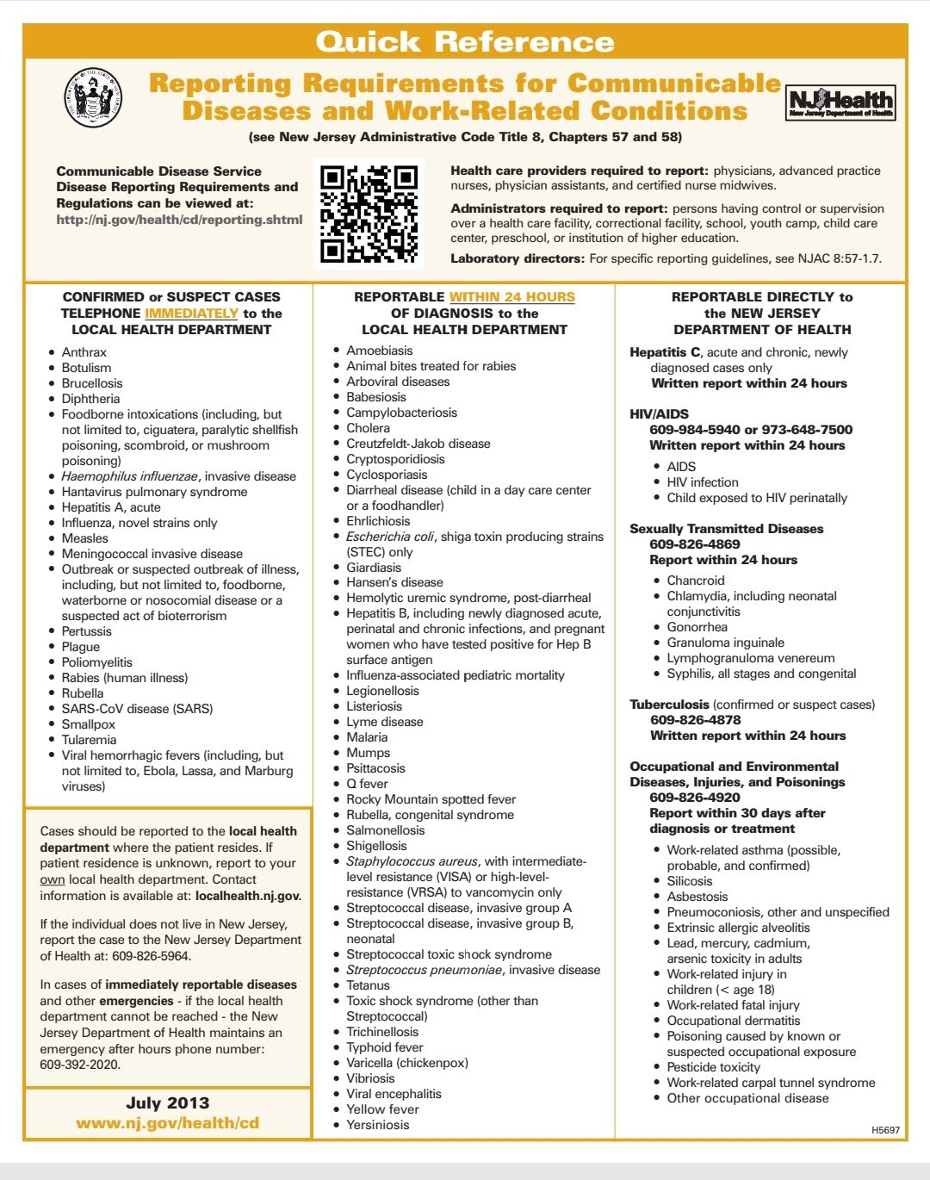
SIGN: _______________________________ DATE: ____________________
Rising Stars Learning Center
Photography Consent Form

Rising Stars Learning Center likes to celebrate your child’s work and achievements. Therefore, images of your child and his/her work may appear on our website (risingstarslearning.com or Facebook- Rising Stars Learning Center and Google).

I_____________________________________________ parent/guardian
Of__________________________________________________
Hereby: grant permission/do not grant permission
To Rising Stars Learning Center to take and use the photographs and /or digital images of my child for use in printed publications or materials, electronic publications, school websites, and classroom displays for the duration of /her time here.

SIGNED: __________________________ DATE: _________________________
SIGNATURE OF PARENT/GUARDIAN

Rising Stars Learning Center

Parent Handbook
Of Policies & Procedures

201 Veterans Parkway & 201 Sunset Rd,
Willingboro, NJ 08046
(609) 871-0835/ (609) 871-0825

Dear Parents:
Welcome! This Parent Handbook was developed to give you a complete outline of the daycare operations for the Rising Stars Learning Center.

Rising Stars Learning Center believes in the following quote:
“Learning for labor, before we grow old
for learning is better than silver and gold;
Silver and gold will vanish away,
but a good education will never decay”.

Philosophy:
To provide a secure and safe learning environment for all children that encourages self-expression (care for self) and group responsibility (care for others); offers an arena through which your children may discover and express their personal potential through exploration and experimentation. Parents should feel good about bringing their children to a safe, nourishing environment. It is my privilege to ensure that every child experiences these basic rights.

Program:
Our programs vary to fit the needs of you and your child. We provide high-quality care for full- or
Part-time children ages 18 months to 12 years. Breakfast, lunch, and an afternoon snack are prepared in accordance with federal food guidelines and are served to the children in "family style”. Activities are scheduled; however, we often follow child-initiated activities to encourage curiosity and wonder about life.

Curriculum:
Our center uses The Creative Curriculum, a research-based approach that promotes learning through play, exploration, and discovery. Daily activities balance teacher-guided learning, group activities, and independent play to support children's social, emotional, physical, cognitive, and language development.

My Training and Experience:
I hold a master’s degree in political science and criminal justice and am pursuing a Doctorate in Early Childhood Education. With 26 years of experience working with children of all ages, I have taught science, Spanish, and social studies in educational and social service settings. I am also trained in CPR, First Aid, Conflict Resolution, ADD, and classroom management.
Hours of Care:

6:00 a.m. to 5:30 p.m., Monday to Friday except on the days as mentioned below.

Statutory Holidays: We will be closed on all statutory holidays as follows:
Labor Day, Thanksgiving Day- Day After, Christmas Day- day after or before, New Year’s Day, Martin Luther King Jr. Birthday, President’s Day, Good Friday, Memorial Day, Juneteenth Day, Fourth of July, and one-week break at the end of August.

We will be closed on the following days in 2026

January 1 | New Year's Day
January 19 | Martin Luther King Jr. Day
February 16 | Presidents’ Day
April 3 | Good Friday
May 25. | Memorial Day
June 19 | Juneteenth Day
July 3 | Independence Day
August 26- Sept 2nd | School Break
September 7 | Labor Day
November 26 & 27 | Thanksgiving Day
December 24th | Christmas eve
December 25th | Christmas Day

Early Closings: Rising Stars Learning Center will close on the following days
November 26 & 27
Christmas Eve, Christmas, and New Year’s Day.

Other Notices: The center will be closed for unexpected incidents like inclement weather, family
emergencies, etc. Parents will receive as much notification as possible in these
instances. Please call me @ 609-227-9784 when it snows.

Admission and Enrolment Procedures:
Interview Procedures: Rising Stars Learning Center will not accept any family into care without conducting
complete interview, in which both parties must feel comfortable and confident that the arrangements will work.

Registration Package: All parents MUST read, complete, and sign all paper forms in the package

Registration Fee: There will be a non-refundable registration fee of $100.00 for all first-time enrolling children.

*Tuition:
Tuition fees are based on the following:
Full day is 4+ hours, flat fee
Part-time is 3 days or 4 hours per day for five days flat fee
Drop-in rates are on a day-to-day basis

Releasing Your Child:
Your child will only be released from care to those persons listed on your Registration Form. If someone other than designated persons will be picking up your child, I must receive advance notice by calling and texting, or your child WILL NOT be released. Notification will include the person’s full name, address, telephone number, relationship to the child, and other pertinent information to help me identify the person. Once I have been notified that another designated person will be picking up your child, I will require a picture ID and other proof of identification from that person BEFORE releasing your child. This is a security measure for all involved.

Parents will be notified immediately if someone not on the list comes to pick up their child. Please take the time to talk with me about any custody issues relating to your child.

Please Note: Rising Stars Learning Center will not release a child to a parent or Guardian who comes to the daycare clearly under alcohol unless there is a
designated driver. That driver must accompany the parent to the door so
that we can ensure the child’s safety prior to releasing him/her.

Likewise, Rising Stars Learning Center will not release a child to a designated pick-up person or a parent when appropriate child seating is unavailable in the transporting vehicle. In both instances, Rising Stars Learning Center has a legal obligation to call the police if a child leaves, despite my best intentions at the point in time. Should this happen, I will be forced to terminate the care.

Parent Involvement
Rising Stars Learning Center operates under an Open Door Policy. Parents are welcome to visit the center at any time and at any location where their child will receive care. However, parents are asked to respect nap times, so they do not disturb the children.

Parents who would like to take an active part in their child’s care are more than welcome to do so. Whether you chaperone field trips or offer suggestions for crafts, snacks, reading, math, science, or anything else, your input is valuable.

We will post weekly menus, activity charts, and other information on the bulletin board to let parents know what is happening at the center. A monthly newsletter will be published to inform parents of events that will occur during that month. This is part of our learning and developmental activities; the children love it.

Health & Sick Child Policies:

Please review this section carefully because children get sick without warning. Therefore, parents are advised to have a backup childcare plan.

For the health of all the children in the center, I have the right to refuse care of a sick child.
I also reserve the right to determine when a child is too ill to remain in care. Please DO NOT bring your
child to care if he/she has the following symptoms:

- Fever over 100.4F / 38C degrees taken orally Head lice
- Nausea, vomiting, and diarrhea yellow skin or eyes
- Eye infections, i.e., conjunctivitis (pink eye) severe cold, and/or cough
- Rash with a fever Rapid or labored breathing
- Sore throat Ear infection
- Contagious illnesses like measles, chickenpox, mumps, etc.

Parents MUST notify the center immediately if their child becomes infected with a
contagious disease so that the other parents can be notified.

A child presenting any of the symptoms noted above while in care will be isolated for the protection of the other children and the parents or emergency contact person will be notified to pick up the child immediately. Your child will be kept as comfortable as possible until you arrive.

A child with a fever MUST be fever-free for 24 hours before he/she will be accepted back into care.

Administering Medication

Medication will only be administered to your child under the following circumstances:
- All medication is in the original container with your child’s name, proper instructions, Dr.’s name, and telephone number.
- Medication is accompanied by instructions regarding dosage, times to administer the dose, and signs of allergic reactions.
- Parents complete and sign a Permission to Administer Medication Form and a Medication Administer Form. This form will be used to document the times, dosage, and signs of any allergic reactions. A separate form must be filled out for each medication your child requires.
- Parents take the time to go over the information with me so that the instructions are clearly understood.

Emergencies:

Medical: In the event of an emergency, parents or the designated emergency contact person will be contacted immediately unless the injury/illness proves to be life-threatening, at which time the first call priority will be to 911, the hospital, doctor, poison control, etc. To secure emergency medical care for your child, parents MUST complete and sign all medical emergency permission forms.

Minor scratches, cuts, and similar injuries will be treated with basic first aid, including cleaning the wound with water and bandaging. Parents will be notified of these injuries immediately upon their arrival to pick their child up and will be given an Accident/Injury Report.

Fire: The children at Rising Stars Learning Center will practice monthly fire drills so they know what to do in the event of a fire.

The children have been taught to evacuate the building immediately.

Proceed to the end of the sidewalk and wait there. We will continue practicing our stop, drop, and roll techniques and crawling on our bellies to the exits.

Child Abuse:
Childcare providers are all required by law to report any suspected cases of child abuse or neglect.

Termination of Care:
Parents are required to provide two weeks notice of termination of care after the two-week trial
period has expired. Failure to do so will result in loosing any advance pay made equal to the
amount of notice not provided.

The provider will give parents two weeks notice of termination of care except under the following circumstances at which time she reserves the right to terminate all care without notice:
- Failure to abide by the policies in this handbook.
- Failure to abide by the terms set out in the childcare contract.
- Failure to make payments on time or not paying for care at all.
- Failure to repeatedly not pick up your child at the agreed upon time.
- Failure to complete all required forms in the Registration Package.
- Inability of the parents and provider to communicate effectively.
- Inability of the child to adjust to the childcare being provided after a reasonable amount of time.
- Provider’s inability to meet the needs of the child after exhaustive efforts to do so.
- Child’s behaviour is disruptive to the rest of the children in the day home.

I_____________________ have received and hereby sign a copy of the Parent Handbook.

Sign: __________________

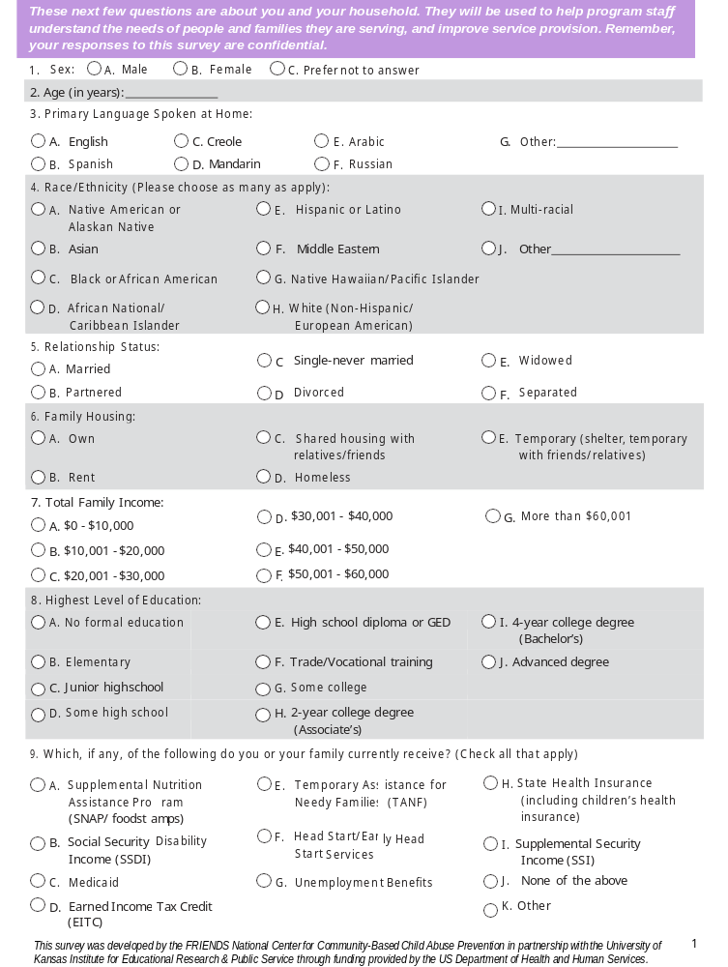
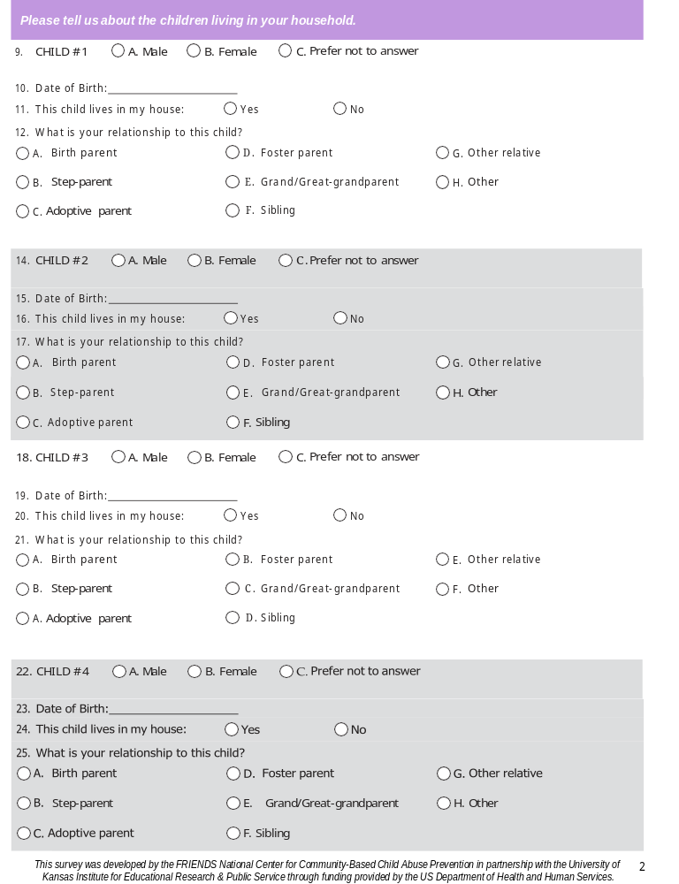
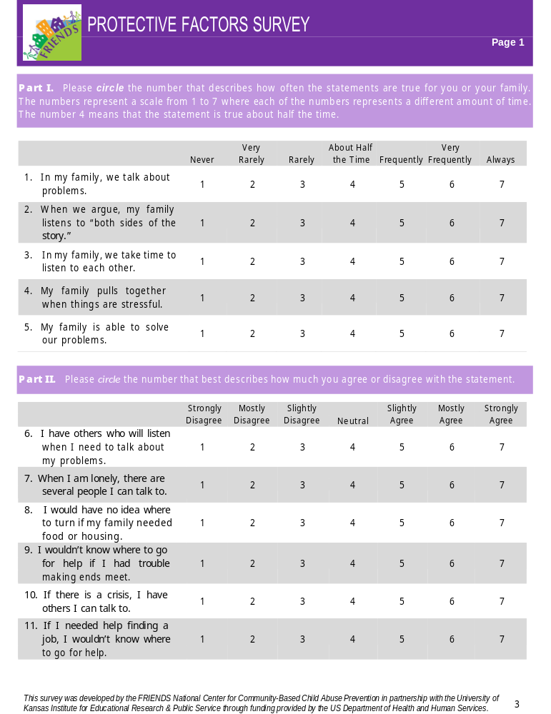
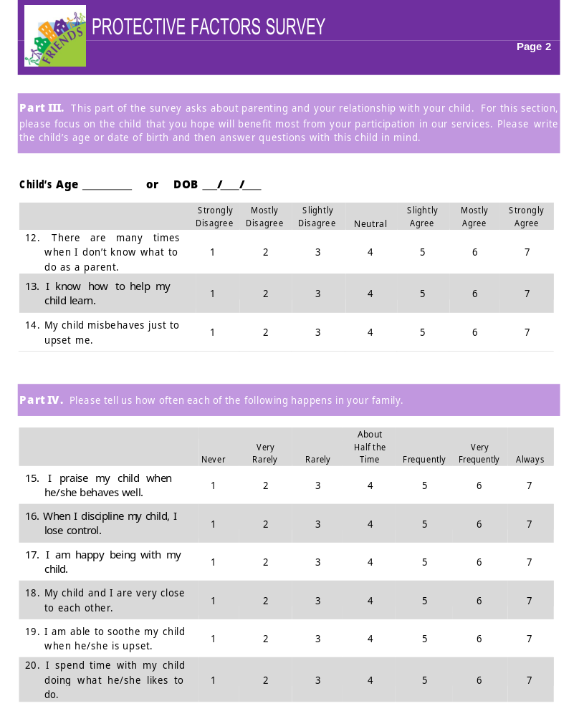

Parent will be provided with a copy of the ASQ 3 AND ASQ 2 SE Developmental Assessment upon admission


Transportation

This Transportation Agreement (the "Agreement") is entered into between:
(Parent’s name) ___________________________ and Rising Stars Learning Center.
For the transportation of: (Child/Children’s name) __________________________________________________
For the sole purpose of transportation to and from school
The daycare transportation services will be provided according to the schedule agreed upon by the daycare provider and the parent/guardian. Any changes to the schedule will be communicated in advance.

In the event of an emergency during transportation, the daycare provider will make reasonable efforts to contact the parent/guardian and emergency contacts.
Parent/Guardian Signature: _________________________
Date: ________________________

