Fircone Ambling A006 (Wednesdays)
Programme May to August 2026

Date |  | Walk, General info, Meeting place and transport details | Leader | Meeting  Time
6.5 | Returning | Bluebell walk. Lydiate Ash, Beacon Hill, Lickey VC Cofton. 5 miles Linear. Mixed 3* meet PQ2 (Square Peg) at 10.00 for 10.05 X20. Return by bus. | Ian & Andrea  07947000515 | 10.00
13.5 | WA4 | Pelsall to Brownhills 4.1 miles. Linear. Mixed 2* Meet New St station for 10.30 train to Walsall. Return by bus | Phil  07966806947 | 10.20
20.5 | SWB 5 | Waseley Hills Circular . 4.6 miles Circular. Mixed 5* Meet NS 3 for No.63 bus at 10.33. Return by bus. | Steve  07305298865 | 10.25
27.5 | SW8 | Kenilworth, Town, Abbey Fields and Castle.3.5 miles. Circular. Mixed 2* Meet New St station for 10.21 to Coventry. Transfer to X17 bus on bridge at 10.58. Return by bus to Coventry & train back to Birmingham. | Clive & Christine  07594236066 | 10.10
3.6 | SB3 | Moseley Bog, Swanshurst and Chinbrook. 4.5 miles. Linear 2* Mixed. Meet MS 16 for 10.25 No 5 bus to Sarehole Mill. Return by bus or train | Allan  07956376996 | 10.20
10.6 | New  SF12 | Lichfield to Shenstone via Wall 4.5 miles Linear. Mixed 5*. Meet new St station for 10.36 train to Lichfield City. Return by train from Shenstone. All pay. Blake St. to Lichfield City return. £5.20/£3.45 | Bob  07766654919 | 10.25
17.6 | Returning | Arrow Valley Country Park by Car. Circular Mainly tarred. Lifts and pick ups to be arranged beforehand. | Andrea & Ian  (as above) | Arrive 11.00
24.6 | SW 23  New | Birmingham Erratic Trail No.2 3 miles 2* Meet Ns 4 for 10.35 No.45 bus. Return by bus from Bournville. | Phil (as above) | 10.25
1.7 | New | Warwick Parkway Circular. 4.7 miles. Circular. Mixed/towpath.3* Meet Moor St. Station for 10.45 Chiltern to Warwick Parkway. (All pay Dorridge to W. Parkway return. £7.50/£4.95) | Tony  07530532006
8.7 | SWB12 | Man on the Moon to Alvechurch Railway Station. 5 miles. Linear. Mixed 2* Meet NS 4 for 10.20 No.45 bus to Man on the Moon. Return by train. (All pay Alvechurch to Longbridge. £3.90/£2.55) | Steve  (as above) | 10.15
15.7 | WB3 | Sandwell Valley, Forge Mill to Dartmouth Park 4.5 miles. Linear. Mixed. 2* Meet MS 10 for 10.27 No.16 bus to Hamstead. Return by tram. | Allan  (as above) | 10.20
22.7 | WV5 | Bushbury to Wednesfield. 4.5 miles. Linear. Mixed. Meet New St Station for 10.22 train to Wolverhampton. Transfer to bus station for No.32 bus. Return by bus/train. | Tony  (as above) | 10.15
29.7 | SW18 | Stourbridge Town to the Red House. 2.9 miles. Linear. Mixed. Meet Snow Hill Station for 10.31 train to Stourbridge. Return by bus and train. | David  01212432243 | 10.20
5.8 | NB2 | Clarence Road to Sutton Park and Town Gate 5 miles. Linear 2* Mixed. Meet PQ 3 (Square Peg) for X3 bus at 10.37 to Clarence Road. Return by train from S. Coldfield. | Bob  (as above) | 10.30
12.8 | Sol R4 | Hampton to Solihull.5 miles. Linear 2* Mixed. Meet New St. Station for 10.36 train. Return by bus or train. | Tony  (as above) | 1025
19.8 | M1 | Meriden, Eaves Green, Meriden. 4.8 miles. Circular. Mixed. 2* Meet Side of Moor St. Station for X1 bus at 10.25. Return by bus. | Christine & Clive  (as above) | 10.20
26.8 | SW9 | A Tale of 2 Bloxwichs 3.2 miles. Mixed 1* Circular..Meet New St Station for 10.45 train to Bloxwich North. Return by train. | Phil  (as above) | 10.35
Fircone Short Walks by A006
May to August 2026
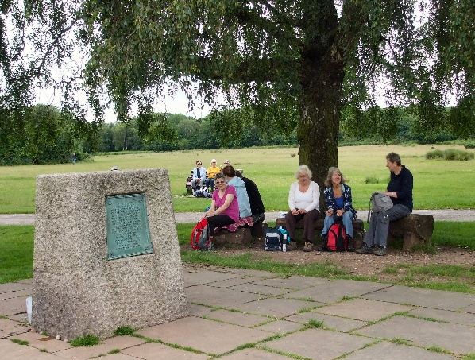
(At the Jamboree stone in Sutton Park)
- On the last Wednesday of each month, we will lead a shorter walk of about 3 miles. It will be easy walking on good paths, pavements and towpaths. There will not be any stiles. Usually there will be a café along the way or at the end or maybe even a pub but bring a picnic if you wish. If you find our regular 4-6 mile walks too much, join us on these gentle strolls and try us out. Bring a friend!

Date | Walk No. | Description | Meeting time and place
27.5 | SW 8 | Kenilworth Town, Abbey Fields and Castle  - Miles  Café in Abbey Fields | New St Station at 10.10 for 10.21 train
24.6 | SW 23  New | Birmingham Erratic Trail No.2  2.7 miles. No café. Bring picnic | NS 4 for 10.25 No.45 bus
29.7 | SW 18 | Stourbridge Town to Red House  2.7 miles  Café in Red House | Meet Snow Hill station at 10.20 for 10.31 train.
26.8 | SW 9 | A Tale of 2 Bloxwichs  3.2 miles  No café. Bring picnic | Meet New St station at 10.35 for 10.45 train

