Touch-a-Truck Event

Free Admission

Hosted by New Hope Academy
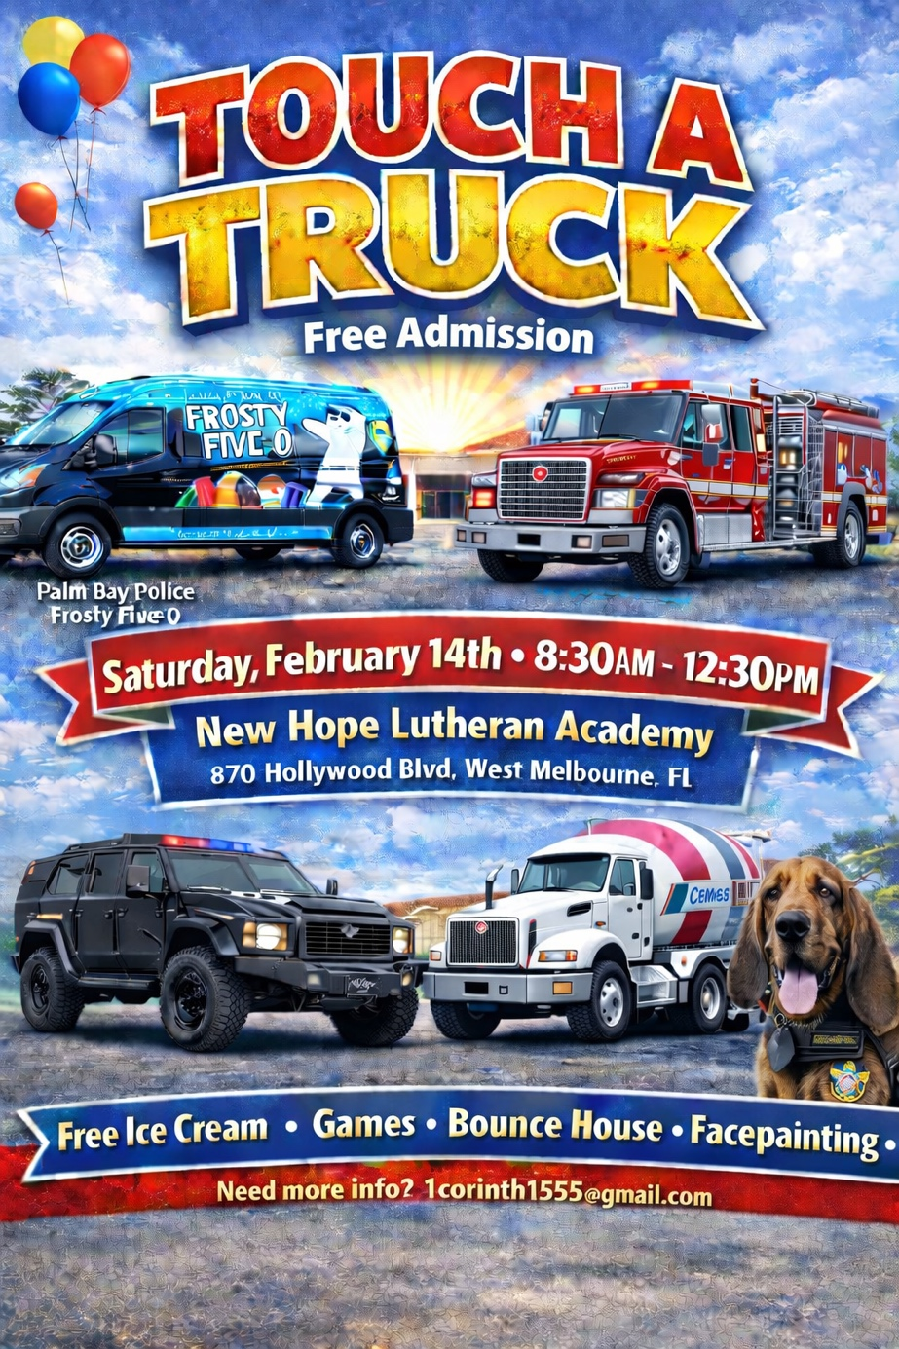
  - Fun for the whole family!
Get ready for a hands-on adventure! Join us for our annual Touch-a-Truck event, where kids and adults can explore, climb, and touch a wide variety of vehicles including fire trucks, SWAT trucks, construction trucks, and more. Meet the heroes who drive them and learn about how these amazing machines work.
As a special community service, parents may request free fingerprinting of their children. Parents keep the print cards. No one else has access to them. This service is provided by the Brevard County Sheriff’s Explorers.

For more information, contact us at 1corinth1555@gmail.com

