[Назва статті] Шрифт Calibri Bold 17

[Автор(и)] Шрифт Times New Roman 11

1 Tampere University of Applied Sciences, Kalevantie 4 33100 Tampere, Finland

2 University of Twente, Drienerlolaan 5, 7522 NB, Enschede, The Netherlands

3 University of Skövde, Högskolevägen 1, 541 28 Skövde, Sweden Шрифт Times New Roman Italic 9

Abstract Шрифт Calibri Bold 11

[Напишіть анотацію сюди] Шрифт Times New Roman 9 , відступи не міняємо.

Keywords

[Вкажіть ключові слова] Шрифт Times New Roman 9

# Introduction Шрифт Calibri Bold 14

[Напишіть текст розділу тут] Мінімальний обсяг «короткого повідомлення» 6 повних сторінок, повної статті – 10 повних сторінок Шрифт Times New Roman 11

# Research methodology.

[Напишіть текст розділу тут] ПОЯСНЕННЯ РИСУНКІВ, ТАБЛИЦЬ ТА ПОСИЛАННЯ НА НИХ ОБОВ’ЯЗКОВО.

Зверніть увагу на нижній колонтитул на першій сторінці!!!

Шрифт Times New Roman 11

In this section, you can find an example of table styling. Note that captions are placed *above* tables. It is recommended to add cross references to tables, i.e., please, check Table 1.

The style of texts within tables should be Normal.

**Table 1**

Frequency of Special Characters

|  |  |  |
| --- | --- | --- |
| Non-English or Math | Frequency | Comments |
| Ø | 1 in 1,000 | For Swedish names |
| 𝜋 | 1 in 5 | Common in math |
| $ | 4 in 5 | Used in business |
| Ψ | 1 in 40,000 | Unexplained usage |

Your figures should contain a caption which describes the figure to the reader. Your figures should also include a description suitable for screen readers, to assist the visually challenged to better understand your work.

Figures should be centered, and their captions should be placed below them.

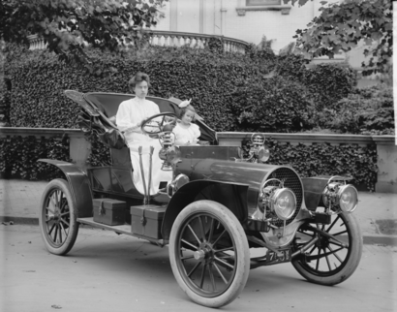

**Figure 1:** 1907 Franklin Model D roadster. Photograph by Harris & Ewing, Inc. [Public domain], via Wikimedia Commons. (<https://goo.gl/VLCRBB>).

Equations

An Example of equation

|  |  |
| --- | --- |
| $$E=mc^{2},$$ | (1) |

where ...

An example of the Figure 1, which also uses cross-reference. The style should be switched to Normal.

# Results and analysis

[Напишіть текст розділу тут]

ТЕКСТИ ПРОГРАМНОГО ЗАБЕЗПЕЧЕННЯ ВИЛУЧИТИ Шрифт Times New Roman 11

# Discussion

[Напишіть текст розділу тут] Шрифт Times New Roman 11

# Conclusion

[Напишіть текст розділу тут] Шрифт Times New Roman 11

Declaration on Generative AI

*Either:*

The author(s) have not employed any Generative AI tools.

*Or (by using the activity taxonomy in ceur-ws.org/genai-tax.html):*

During the preparation of this work, the author(s) used X-GPT-4 and Gramby in order to: Grammar and spelling check. Further, the author(s) used X-AI-IMG for figures 3 and 4 in order to: Generate images. After using these tool(s)/service(s), the author(s) reviewed and edited the content as needed and take(s) full responsibility for the publication’s content.

Шрифт Times New Roman 11

References

**Мінімум 15 джерел, 75% ЗА ОСТАННІ РОКИ та non native. Самоцитування не більше 15%**

1. [Додайте джерело] Шрифт Times New Roman 11